
Answer five questions including question 1.
Q1. When you see an object through the eye door, a series of consciousness arise in a particular order. Illustrate this fact in detail with an example.
Ans 1.
When one sees an object through the 5 sense doors and the mind door, a series of consciousness (citta) arise in a particular order known as the cognitive process (cittavāthi). There are 6 types of cognitive processes.
According to the doors the six cognitive thought processes are:
- The process connected with the eye door
- The process connected with the ear door
- The process connected with the nose door
- The process connected with the tongue door
- The process connected with the body door
- The process connected with the mind door

Or, according to consciousness, the six cognitive thought processes are:
- The process connected with eye-consciousness
- The process connected with ear-consciousness
- The process connected with nose-consciousness
- The process connected with tongue-consciousness
- The process connected with body-consciousness
- The process connected with mind –consciousness

For a cognitive process to occur, such as when one sees an object through the eye door, all the essential conditions must be present. In the case of the eye-door process, the essential conditions are (p.151):
- eye-sensitivity (cakkhuppasāda)
- visible object (rūpārammana), e.g. chair, table, TV, etc.
- light (āloka)
- attention (manasikāra)

When cittas arise cognizing an object at the sense doors or the mind door, they do not occur at random or in isolation, but as phases in a series of discrete cognitive events leading one to the other in a regular and uniform order. This order is called cittaniyāma, the fixed order of consciousness.

The diagram below illustrates the phases of one complete eye-door cognitive process for a very great object:
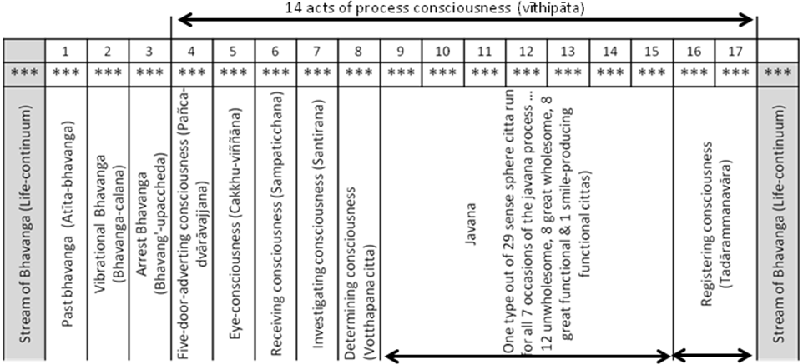
One mind moment consist of 3 sub-moments (***) – arising (uppāda), presence (thiti), and dissolution (bhanga). A mind-moment (cittakkhana) is also the life span of a citta. It is a temporal unit of such brief duration that billions of mind-moments can elapse in the flash of a lightning or the blink of an eye. The entire cognitive process consists of 17 such mind-moments.
When no active cognitive process is taking place, the stream of bhavanga flows on as a series of cittas all of the same type, hanging on to a single object, either a kamma, a sign of kamma, or a sign of destiny, the same as the object of the last javana process in the immediately preceding existence.
1. Atīta-bhavannga - Past life-continuum.
At the very moment a sense object enters a sense door, one bhavaga citta passes, known as atīta-bhavannga, the past life-continuum.
The Atīta-bhavannga - Past life-continuum performs the function of life-continuum (bhavanga).
Owing to the impact of the object, another 2 bhavanga cittas vibrate.
2. Bhavanga-calana - Vibrational life-continuum
The first is known as bhavanga-calana, vibrational life-continuum.
The Bhavanga-calana - Vibrational life-continuum performs the function of life-continuum (bhavanga).
3. Bhavanga-upaccheda - Arrest life-continuum.
The second interrupts the stream of bhavanga is known as the bhavanga-upaccheda, arrest life-continuum.
The Bhavanga-upaccheda - Arrest life-continuum performs the function of life-continuum (bhavanga).
4. Pañcadvārāvajjanacttaŋ - Five-door adverting citta
Thereafter, with the arising of the five-door adverting citta, the stream of consciousness emerges from the “process-freed” state and launches into a cognitive process (vīthipāta). This marks the beginning of 14 cognitive process cittas.
The Pañcadvārāvajjanacttaŋ - Five-door adverting citta performs the function of adverting (āvajjana).
Immediately after, there arise & cease in due order:
5. Cakkhuviññānaŋ - Eye-consciousness, seeing that form.
The Cakkhuviññānaŋ - Eye-consciousness performs the function of seeing (dassana).
6. Sampaticchanacittaŋ - Receiving consciousness, receiving it.
The Sampaticchana – receiving consciousness performs the function of receiving (sampatichannā).
7. Santīranacittaŋ - Investigating consciousness, investigating it.
The Santīranacittaŋ - Investigating consciousness performs the function of investigating (santīranā).
8. Votthapanacittañ - Determining consciousness, determining it.
The Votthapanacittañ - Determining consciousness performs the function of determining (votthapana).
9-15. Javanas
Following this, any one of the 29 sense sphere javanas which has gained the right conditions runs its course, generally for 7 mind moments.
The 29 sense-sphere javanas are 12 unwholesome, 8 great wholesome, 8 great functional and one functional smile producing cittas. Only one type of citta runs for all seven occasions of the javana process.
The Javana performs the function of javana.
16 & 17. Tadārammana vipāka - Registration resultants
After the javanas, 2 registration resultants arise accordingly.
The Tadārammana vipāka - Registration resultants performs the function of registration.
Then comes the subsidence into the life-continuum.

Q2. What are the four fold Abhidhammattha? Give a short introduction of each of them.
Ans 2.
The four fold Abhidhammattha or the four fold ultimate realities (catudhā paramattha – parama = ultimate, attha = reality) are:
- Rupa (Matter)
  - Conditioned realities.
  - The physical side of the being.
  - Matter is twofold in terms of the four great elements (mahābhūta) and the 24 secondary elements derived from the four great elements.
  - There are 4 great elements are Pathavi (Earth), Apo (Water), Tejo (Fire) & Vayo (Wind).
  - Matters originate in four ways, from kamma, consciousness, temperature, and nutriment.

- Nibbānna
- Unconditioned realities.
- Experienced by Supramundane consciousness.
- It signifies the extinguishing of the worldly “fires” of greed (lobha), hatred (dosa), and delusion (moha)
- Attaining Nibbāna is the deliverance from samsara, the cycle of birth and death.

- Cetasika (Mental factors)
  - Conditioned realities.
  - There are 52 cetasika classified into four broad categories:
  - seven universals (aññasamāna)
  - six occasional (pakinnaka)
  - fourteen unwholesome factors (akusala)
  - twenty-five beautiful factors (sobhana)
  - All cetasikas has four characteristics:
  - they arise together with consciousness
  - they cease together with consciousness
  - they have the same object as consciousness
  - they have the same base as consciousness

- Citta (State of Consciousness)
  - Conditioned realities.
  - There are a total of 89 cittas discussed in the Abhidhammattha sangaha.
  - These are classified into four planes of consciousness. The 3 in the mundane planes are the sense sphere (kāmāvacara), the fine-material sphere (rūpāvacara) and the immaterial sphere (arūpāvacara). The fourth plane is the Supramundane (lokuttara).
  - As an activity citta refers to the process of cognizing an object and that act is impermanent, marked by rise and fall.
  - Its characteristic is the knowing of an object (vijānana)
  - Its function is to be a “forerunner” (pubbangama) of mental factors in that it presides over them and is always accompanied by them.
  - Its manifestation, the way it appears in the mediator’s experience, is as a continuity of process (sandhāna).
  - Its proximate cause is mind-and-matter (nāmarūpa), because consciousness cannot arise alone, in complete absence of mental factors and material phenomena.

Q3. How is feeling (vedanā) explained? Name the cittas which fall under each category of feeling.
Ans 3.
Feeling (vedanā) is a universal mental factor, the cetasika with the function of experiencing the “flavour” of the object. Since some sort of feeling accompanies every citta, feeling serves as an important variable in terms of which consciousness can be classified.
Feeling may be analyzed as either three fold or five fold.
When it is analyzed simply in terms of its affective quality, it is threefold:
- Pleasant (physical and mental)
- Painful (physical and mental)
- Neither-painful-nor-pleasant
The five fold analysis of feeling (vedanā) are:
Physical:
- Pleasure (Sukha) – has the characteristics of experiencing a desirable tangible object, the function of intensifying associated states, manifestation as bodily enjoyment, and its proximate cause is the body faculty.
- Pain (Dukha) – has the characteristics of experiencing an undesirable tangible object, the function of withering associated states, manifestation as bodily affliction, and its proximate cause is also the body faculty.
Mental:
- Joy (Somannasa) – has the characteristics of experiencing a desirable object, the function of partaking of the desirable aspect of the object, manifestation as mental enjoyment, and its proximate cause is tranquillity.
- Displeasure (Dommanasa) – has the characteristics of experiencing an undesirable object, the function of partaking of the undesirable aspect of the object, manifestation as mental affliction, and its proximate cause is the heart base.
- Equanimity (Upekhā) - has the characteristics of being felt as neutral, the function of neither intensifying nor withering of associated states, manifestation as peacefulness, and is proximate cause is consciousness without zest.

The number of consciousness accompanied by each of these fivefold feelings are:
Feeling  (Vedanā) | Pleasure  (Sukha) | Pain  (Dukha) | Joy  (Somannasa) | Displeasure  (Domanassa) | Equanimity  (Upekha)
Consciousness (Citta) | 1 | 1 | 62 | 2 | 55
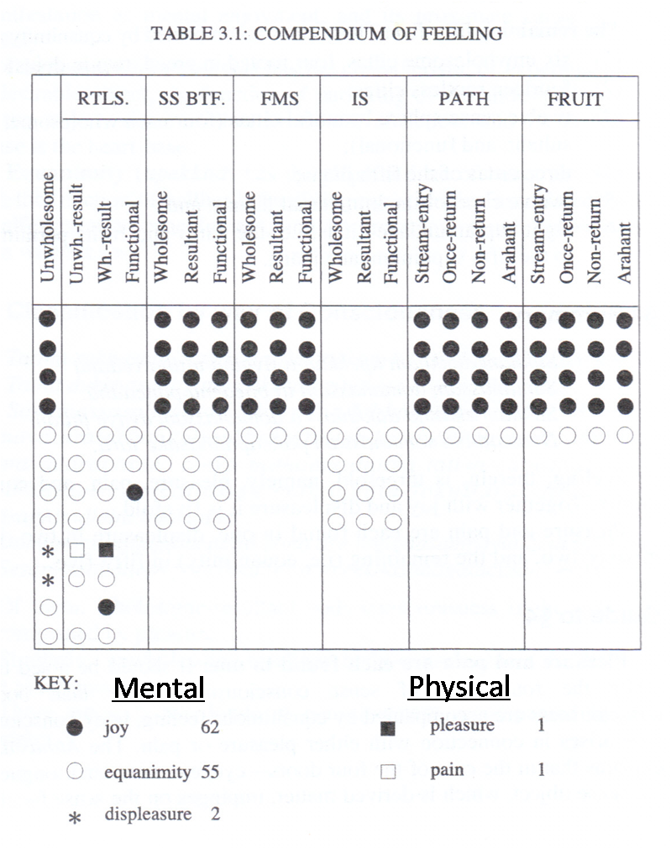
Q4. Give a description of the four planes of existence as discussed in the Process-freed chapter.
Ans 4.
The four planes of existence are:
- The woeful plane (sense-sphere plane) – Apāyabhūmi
This refers to the realms of existence where pain and misery greatly exceed happiness. They are the realms where evildoers are reborn as a consequence of their evil deeds.
The woeful plane is fourfold, namely:
- Hell (niraya) – It is the lowest plane of existence in the Buddhist cosmos, the place of intense suffering. It is said that the beings in hell have to suffer the results of their evil deeds from the beginning of their lives until the end. There are 8 great hells surrounded on each of its four sides by 4 minor hells, bringing the total to 136 hells.
- The animal kingdom (tiracchān yoni) – The animal realm does not involve as much misery as hells but the suffering there greatly exceeds the amount of happiness. It does not provide suitable conditions fro the performance of meritorious deeds.
- The sphere of petas (petas yoni) – Often referred to as the “hungry ghosts” realm, petas are a class of beings who are tormented by intense hunger and thirst as well as other afflictions from which they cannot find relieve. The petas have no world of their own. They live in the same world as human beings in forests, bogs, cemeteries, etc. Though they remain invisible to humans except when they display themselves or are perceived by those with the divine eye.
- The host of asuras (asura yoni) – Referred to as “titans”, the asuras are a group of tormented spirits similar to the petas.

- The sensuous blissful plane (sense-sphere plane) – kāmasugatibhūmi
The sensuous blissful plane is sevenfold, namely:
- The Human realm (manussā) – The human mind, which is very sharp, is capable of development up to Buddhahood, and also of such serious crimes as matricide and patricide. The human realm is a mixture of both pain and pleasure, suffering and happiness, but because it offers the opportunity for attaining the highest happiness, it is considered a blissful realm.
- The Realm of the Four Great Kings (cātummahārājikā) – The first of the six sense sphere heavens, the abodes of the devas or gods. This realm has 4 divisions corresponding to the four directions. Each is inhabited by a different class of demigods and ruled over by its own guardian deity.
Direction | East | South | West | North
King | Dhatarattha | Virūlhaka | Virūpakkha | Vessavana
Demigods | Gandhabbas  (The celestial musicians) | Kumbhandas  (The gnomic caretakers of forests, mountains and hidden treasures) | Nāgas  (demigods in the form of dragons) | Yakkhas  (Spirits)

- The Realm of the Thirty-three Gods (tāvatimsa) – This heaven is so named because according to legend a group of 33 noble-minded men who dedicated their lives to the welfare of others were reborn here as the presiding deity with 32 assistants. The chief of this realm is King Sakka, also known as Indra, who resides in the Vejayanta Palace in the realm’s capital city, Sudassana.
- The Realm of the Yāma Gods (yāmā) – The realm of great happiness presided over by King Suyāma or Yāma.
- The Delightful Realm (tusitā) – The abode of Bodhisatta in his last existence before attaining Buddhahood.
- The Realm of the Gods who rejoice in their own Creations (nimmānarati) – the gods have the power to create objects of sensual enjoyment by thought, in accordance with their desires.
- The Realm of the Gods who lord over the Creations of Others (paranimmitavasavattī) – The gods control the objects of enjoyment created for their use by their attendants.
The fourfold woeful plane and the sevenfold sensuous blissful plane constitute the sense-sphere plane.
- The fine-material-sphere plane – rūpavacarabhūmi
This is the realm of rebirth for those who have developed, during their life, the fine-material jhānas, and at the time of death still possess that jhāna.
The fine-material-sphere plane is 16 fold:
- The first jhana plane – 3 realms
- The second jhana plane – 3 realms
- The third jhana plane – 3 realms
- The fourth jhana plane – 2 realms
- The Pure Abodes (suddhāvāsa) – 5 realms
- The immaterial-sphere plane - arūpavacarabhūmi
The immaterial-sphere plane is fourfold, namely:
- The realm of infinite space
- The realm of infinite consciousness
- The realm of nothingness
- The realm of neither-perception-nor-non-perception
These are the 4 planes of rebirth for those who, at the time of death, possess an immaterial meditative attainment. Each immaterial attainment leads to rebirth into the corresponding realm.
Q5. What consciousness do the function of “Javana”? Name them under the planes of existence.
Ans 5.
A total of 55 cittas do the function of “Javana”. The 55 cittas perform the function of javana occur solely in the role of javana and do not perform any other functions. A summary of the number of javana cittas classified under the planes of existence are as follows:
Type of Plane  (55) |  | Unwholesome  (Akusala)  (12) | Wholesome  (Kusala)  (21) | Resultant  (Vipaka)  (4) | Functional  (Kriya)  (18)
Sense Sphere  (Kamavacara)  (29) | Unwholesome  (12) | 12
Sense Sphere  (Kamavacara)  (29) | Rootless  (1) |  |  |  | 1  (Exclude 2 adverting cittas)
Sense Sphere  (Kamavacara)  (29) | Beautiful  (16) |  | 8 |  | 8
Fine material Sphere  (Rupavacara)  (10) |  |  | 5 |  | 5
Immaterial Sphere  (Arupavacara)  (8) |  |  | 4 |  | 4
Supramundane  (8) |  |  | 4 | 4

The 55 cittas under the planes of existence are as follows:
1. 29 sense sphere cttas:
A. 12 sense sphere unwholesome cittas
a. 8 are rooted in greed (lobha):
- Somanassa sahagatam ditthigata sampayuttam asankharikam
- Somanassa sahagatam ditthigata sampayuttam sasankharikam
- Somanassa sahagatam ditthigata vippayuttam asankharikam
- Somanassa sahagatam ditthigata vippayuttam sasankharikam
- Upekkha sahagatam ditthigata sampayuttam asankharikam
- Upekkha sahagatam ditthigata sampayuttam sasankharikam
- Upekkha sahagatam ditthigata vippayuttam asankharikam
- Upekkha sahagatam ditthigata vippayuttam sasankharikam

b. 2 are rooted in hatred (dosa):
- Domanassa sahagatam pathiga sampayutam asankharikam
- Domanassa sahagatam pathiga sampayutam sasankharikam

c. 2 are rooted in delusion (moha):
- Upekkha sahagatam vicikiccha (skeptical doubt) sampayuttam
- Upekkha sahagatam udacca (restlessness) sampayuttam

B. One sense sphere rootless citta, excluding the 2 adverting consciousness:
i. Somanasasahagatam hasitupādda
- Smile producing consciousness accompanied by joy.
C. 16 beautiful (sobhana) cittas, 8 wholesome (kusala) and 8 functional (kriya):
- Somanassa sahagatam nana sampayuttam asankharikam
- Somanassa sahagatam nana sampayuttam sasankharikam
- Somanassa sahagatam nana vippayuttam asankharikam
- Somanassa sahagatam nana vippayuttam sasankharikam
- Upekkha sahagatam nana sampayuttam asankharikam
- Upekkha sahagatam nana sampayuttam sasankharikam
- Upekkha sahagatam nana vippayuttam asankharikam
- Upekkha sahagatam nana vippayuttam sasankharikam

2. 10 Fine Material Sphere (Rupavacara) cittas, consisting of 5 wholesome (kusala) and 5 functional (kriya):
- Vitakka vicara piti sukha ekagatam pathama jjhana kusalacittam
- Vicara piti sukha ekagatam dutiya jjhana kusalacittam
- Piti sukh ekagatam tatiya jjhana kusalacittam
- Sukh ekagatam chatutta jjhana kusalacittam
- Upekkh ekagatam pancama jjhana kusalacittam

3. 8 Immaterial Sphere (Arupavacara) cittas, consisting of 4 wholesome and 4 functional:
- Infinity of Space
- Infinity of Consciousness
- Nothingness
- Neither Perception nor non-perception

4. 8 Supramundane cittas, consisting of 4 wholesome (kusala) path (magga) and 4 resultant (vipaka) phala (fruit):
- Sotapatti
- Sakadagami
- Anagami
- Arahatta
Q6. Wholesome or moral consciousness are found in all four planes of existence (Bhumi). What difference do you notice according to their functions.
Ans 6.
The wholesome consciousness found in each of the four planes of existence is:
Sense-sphere: 8 wholesome beautiful consciousness.
Fine-material sphere: 5 wholesome sublime consciousness
Immaterial sphere: 4 wholesome sublime consciousness
Supramundane: 4 supramundane path consciousness
These 21 wholesome consciousness all perform the function of javana (p. 127).
(P. 176) In the sense sphere cognitive process, the general rule is for the javana to run 7 times, though in a limited javana process if the object is extremely weak, they may run only 6 times. In the last javana process preceding death, and at times such as fainting, the javanas run only 5 times because of the weakness of the heart base.
The sublime javanas for a beginner during the first (cognitive process of) absorption, and the direct –knowledge javanas always, run only once owing to the weakness due to the lack of repetition. Then comes subsidence into the life-continuum. The javana of the fifth jhāna that performs the role od direct knowledge (abhiññā) always occurs for only one occasion, even in those who have mastered it, because a single occasion is sufficient for it to accomplish its task.
The arising of the 4 paths endures for only one javana mind-moment, during which it accomplishes the abandoning of the defilements to be eradicated or attenuated by that particular path. Thereafter, two or three occasions of fruition consciousness arise according to the case. Then comes subsidence into the life-continuum.
At the time of the attainment of cessation, the fourth immaterial javana runs twice and then contacts cessation. When emerging from cessation, either the fruition consciousness of non-returning or fruition consciousness of Arahantship arises accordingly for a single occasion. When it ceases, there is subsidence into the life-continuum.
Non-returners and Arahants who have mastery over all fine-material and immaterial jhānas can, by mental development, enter a meditative attainment in which the stream of consciousness and its concomitants is temporarily arrested. In such a state – known as nirodhasamāoatti, the attainment of cessation – all mental activity has ceased, though the body remains alive retaining its vital heat.
In the cognitive process of attainments, as in the stream of the life-continuum, there is no fixed procedure regarding the processes. For beginners the attainment occurs for only one javana moment. With practice the attainment can gradually be increased to 2, 3, 4 javannas, etc., while for those who have achieved mastery over the attainment absorption cittas occur in unbroken succession for long periods of time, even days on end.
Q7. Write short notes on any four of the following:
(i) Kāmāvacara
Kāmāvacara means sense sphere. Sense sphere consciousness (kāmāvacara citta) includes all those cittas that have their proper domain in the sensuous plane of existence (kāmabhūmi), though they may arise in other planes as well.
There are a total of 54 kāmāvacara citta as follows:
Sense-sphere consciousness (kāmāvacara citta) |  | Unwholesome (Ākusalā) | Wholesome (Kusala) | Resultant (Vipāka) | Functional (Kiriya)
Sense-sphere consciousness (kāmāvacara citta) | Unwholesome (Ākusalā) | 8+2+2
Sense-sphere consciousness (kāmāvacara citta) | Rootless (Ahetuka) |  |  | 7+8 | 3
Sense-sphere consciousness (kāmāvacara citta) | Beautiful (Sobhana) |  | 8 | 8 | 8

(ii) Abstinences (p. 97)
Among the 52 mental factors (cetasikas), 3 are known as abstinences (virati). They are:
a. Right speech
b. Right action
c. Right livelihood
In the supramundane path (magga) &fruit (phala) cittas, the 3 abstinences are always present together as part of the Noble Eightfold Path. But in mundane cittas they are only present on occasions when one deliberately refrains from wrongdoing.
Since they need to be deliberately exerted in mundane consciousness, they do not occur in:
a. sublime cittas, which take the counterpart sign of jhāna as their object
b. resultant sense-sphere cittas, which do not exercise the function of restraint
c. the great functional cittas of an Arahant, since the Arahant has altogether overcome the disposition towards transgression and thus has no need for abstinence.
Since transgressions in speech, action & livelihood each have a different sphere, in mundane consciousness the 3 abstinences are mutually exclusive. If one is present, the other 2 must be absent.

(iii) Upādaya Rupa
Matter is twofold: a) 4 Great Essentials (mahābhūta)
b) 24 material phenomena derived (upādāya rūpa) from the mahābhūta.
The twenty eight material phenomena, constitute 11 categories as folllows:
Concretely Produced Matter (18)  (Nipphannarūpa) | Non-Concrete Matter (10)  (Anipphannarūpa)
- Great Essentials (Mahābhūta) (4)  - Extension/Earth element (Pathavī dhātu)  - Cohesion/Water element (Āpo dhātu)  - Heat/Fire element (Tejo dhātu)  - Motion/Air element (Vāyo dhātu)  - Sensitive Phenomena (Pasādarūpa) (5)  - Eye-sensitivity (Cakkhu-pasāda)  - Ear-sensitivity (Sota-pasāda)  - Nose-sensitivity (Ghāna-pasāda)  - Tongue-sensitivity (Jivhā-pasāda)  - Body-sensitivity (Kāya-pasāda)  - Objective Phenomena (Gocararūpa) (4)  - Visible form (Rūpa)  - Sound (Sadda)  - Smell (Gandha)  - Taste (Rasa)  *Tangibility (= 3 elements: earth, fire & air. Cohesion is excluded.)  - Sexual Phenomena (Bhāvarūpa) (2)  - Femininity (Ittha)  - Masculinity (Purisa)  - Heart Phenomenon (Hadayarūpa) (1)  - Heart base (Hadayavatthu)  - Life Phenomenon (Jīvitarūpa) (1)  - Material Physical  Life faculty (Jīvitindriya)  - Nutritional Phenomenon (Kabalīkārāhāra) (1)  - Nutriment (Āhāra) | - Limiting Phenomenon  (Paricchedarūpa) (1)  - Space element (Ākāsadhātu)  - Communicating Phenomena  (Viññattirūpa) (2)  - Bodily intimation (Kāya viññatti)  - Vocal intimation (Vacī viññatti)  - Mutable Phenomena (Vikārarūpa) (3)  - Lightness (Lahutā)  - Malleability (Mudutā)  - Wieldiness (Kammaññatā)  (plus two intimations)  - Characteristics of Matter (Lakkhanarūpa) (4)  - Production (Upacaya)  - Continuity (Santati)  - Decay (Jaratā)  - Impermanence (Aniccatā)

(iv) Aniyatayogī (p.99)
Of the 52 types of mental factors (cetasikas), 11 are called aniyatayogī - unfixed adjuncts. They arise in different kinds of consciousness separately because their particular objects differ. They may or may not arise in those types of consciousness to which they are allied. For instance, issa, macchariya, and kukkucca must arise in a consciousness connected with aversion. One of the three must arise at one particular moment. All the three do not occur simultaneously. Besides they are not bound to be present in such a consciousness. So are the three Abstinences, two Illimitables, Conceit, Sloth and Torpor.
The remaining 41 types are called niyatayogī - fixed adjuncts. They invariably arise in those types of consciousness allied to them.
(v) Moral Roots
(P. 120) The 3 moral roots are non-greed (alobha), non-hatred (adosa) & non-delusion (amoha). They are wholesome when they arise in wholesome cittas and indeterminate when they arise in resultant or functional cittas. In either case, whether wholesome or indeterminate, these 3 roots are beautiful (sobhana) cetasikas.
In the compendium of roots, 12 cittas are with unwholesome roots, 18 are rootless and 59 are with wholesome roots. Out of the 59, the12 sense sphere beautiful cittas without knowledge are with 2 roots, non-greed & non-hate. The remaining 47 are with 3 moral roots.
 | Cittas | 8 | 2 | 2 | 18 | 12 | 12 | 27 | 8
Roots | Cittas | Greed-rooted | Hate-rooted | Delusion-rooted | Rootless | SS. Btf. W. Knwl. | SS. Btf. Wo. Knwl. | Sublime | Supramundane | Total
Greed |  |  |  |  |  |  |  |  |  | 8
Hate |  |  |  |  |  |  |  |  |  | 2
Delusion |  |  |  |  |  |  |  |  |  | 12
Non-greed |  |  |  |  |  |  |  |  |  | 59
Non-hate |  |  |  |  |  |  |  |  |  | 59
Non-delusion |  |  |  |  |  |  |  |  |  | 47
 |  | 2 | 2 | 1 | 0 | 3 | 2 | 3 | 3

(vi) Mahaggata citta
The 15 fine-material sphere cittas & the 12 immaterial sphere cittas are collectively designated as mahaggata (sublime) citta. These cittas are free from hindrancesa and are pure, elevated great states of mind. They termed mundane consciousness (lokiyacitta).
Fine-material sphere is fivefold when divided by way of jhānas. It becomes 15 type when further divided by way of the wholesome, resultant, and functional.
The wholesome fine-material sphere cittas are experienced by worldlings and trainees (sekkha) who develop the jhanas within this life itself. Their corresponding results (vipāka) arise only in the fine-material world, in the beings who have been reborn there as a consequence of developing the jhāna. The 5 functional (kriyā) jhāna cittas are experienced only by Arahants.
All fine material cittas are associated with knowledge & have 3 wholesome roots, non-greed, non-hatred & non-delusion.
Immaterial sphere is fourfold when classified by way of object. It becomes 12 type when further divided by way of the wholesome, resultant, and functional.
The 4 wholesome immaterial sphere cittas are experienced by worldlings and trainees (sekkha) who develop the jhanas within this life itself. Their corresponding results (vipāka) arise only in the immaterial world through rebirth. The 4 functional (kriyā) jhāna cittas are experienced only by Arahants.

Q8. Explain what doors (Dvāra) are and name the cittas that arise in any one of the five sensitive doors.
Ans 8.
The term “doors” (dvāra) is used to metaphorically in the Abhidhamma to denote the media through which the mind interacts with the objective world. In the compendium of doors, there are six doors, namely eye door, ear door, nose door, tongue door, body door, and mind door.
The first 5 doors are material phenomena (rupā), the sensitive matter (pasādarūpa) in each of the 5 sense organ. Each of these serves as a door by which the cittas & cetasikas occurring in a cognitive process gain access to their object, and by which the objects becomes accessible to the cittas & cetasikas.
Unlike the first five doors, mind door (manodvarā) is not material but mental (nāma), namely the bhavanga consciousness. When an object to be cognized by a mind door process, the cittas belonging to that process gain access to the object solely through the mind door, without immediate dependence on any material sense faculty.
46 types of consciousness arise in the eye door:
1 five-door adverting consciousness
2 eye-consciousness
2 receiving consciousness
3 investigating consciousness
1 determining consciousness
29 sense-sphere javanas (12 unwholesome, 8 wholesome, 8 beautiful functional, 1 smile-producing functional)
8 registration (=sense-sphere beautiful resultants; the other three being included under investigating consciousness)

