
Answer five questions including question No. 1 (20 marks each question)
Q1. Illustrate with a diagram and show how an eye door Atimahanta rammana citta vithi runs and name the functions performed at each thought moment.

Ans 1.
Translation: Atimahanta (very great) rammana (object) citta vithi (cognitive process).
The diagram below illustrates the phases of one complete eye-door cognitive process for a very great object:
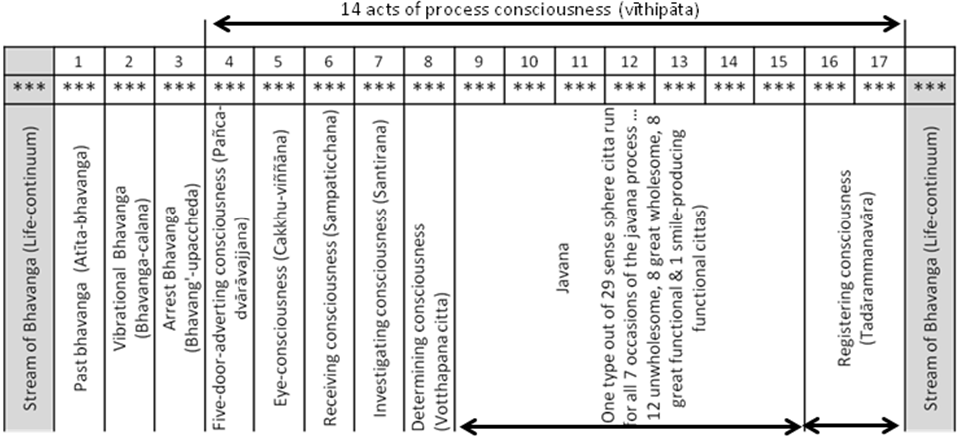
One mind moment consist of 3 sub-moments (***) – arising (uppāda), presence (thiti), and dissolution (bhanga). A mind-moment (cittakkhana) is also the life span of a citta. It is a temporal unit of such brief duration that billions of mind-moments can elapse in the flash of a lightning or the blink of an eye. The entire cognitive process consists of 17 such mind-moments.
When no active cognitive process is taking place, the stream of bhavanga flows on as a series of cittas all of the same type, hanging on to a single object, either a kamma, a sign of kamma, or a sign of destiny, the same as the object of the last javana process in the immediately preceding existence.
1. Atīta-bhavannga - Past life-continuum.
At the very moment a sense object enters a sense door, one bhavaga citta passes, known as atīta-bhavannga, the past life-continuum.
The Atīta-bhavanga - Past life-continuum performs the function of life-continuum (bhavanga). 19 cittas perform this function (p. 126), namely:
- 2 investigating
- 8 great resultants
- 5 fine-material sphere resultants and
- 4 immaterial sphere resultants
The same type of consciousness performs the 3 functions of rebirth-linking, life-continuum, and death (p.125).
- At the moment of conception - this type of consciousness arises linking the new existence to the old one
- Throughout the course of life – this same type of consciousness arises countless times as the passive flow of the bhavanga, maintaining the continuity of existence
- At death – this same type of consciousness again occurs as the passing away from the old existence.
Owing to the impact of the object, another 2 bhavanga cittas vibrate.
2. Bhavanga-calana - Vibrational life-continuum
The first is known as bhavanga-calana, vibrational life-continuum.
The Bhavanga-calana - Vibrational life-continuum performs the function of life-continuum (bhavanga) as above.
3. Bhavanga-upaccheda - Arrest life-continuum.
The second interrupts the stream of bhavanga is known as the bhavanga-upaccheda, arrest life-continuum.
The Bhavanga-upaccheda - Arrest life-continuum performs the function of life-continuum (bhavanga) as above.
4. Pañcadvārāvajjanacttaŋ - Five-door adverting citta
Thereafter, with the arising of the five-door adverting citta, the stream of consciousness emerges from the “process-freed” state and launches into a cognitive process (vīthipāta). This marks the beginning of 14 cognitive process cittas.
The Pañcadvārāvajjanacttaŋ - Five-door adverting citta performs the function of adverting (āvajjana) when a sense object impinges on one of the five physical sense doors.
Immediately after, there arise & cease in due order:
5. Cakkhuviññānaŋ - Eye-consciousness, seeing that form.
The Cakkhuviññānaŋ - Eye-consciousness performs the function of seeing (dassana).
The 2 cittas that perform this function are the wholesome and unwholesome resultant eye-consciousness
6. Sampaticchanacittaŋ - Receiving consciousness, receiving it.
The Sampaticchana – receiving consciousness performs the function of receiving (sampatichannā) by the 2 types of receiving consciousness, wholesome & unwholesome.
7. Santīranacittaŋ - Investigating consciousness, investigating it.
The Santīranacittaŋ - Investigating consciousness performs the function of investigating (santīranā). The 3 cittas that perform this function are
- the investigating rootless unwholesome resultants accompanied by equanimity
- the investigating rootless wholesome resultants accompanied by equanimity
- the investigating rootless wholesome resultant accompanied by joy
8. Votthapanacittañ - Determining consciousness, determining it.
The Votthapanacittañ - Determining consciousness performs the function of determining (votthapana) by the mind-door adverting rootless functional citta.
9-15. Javanas
Following this, any one of the 29 sense sphere javanas which has gained the right conditions runs its course, generally for 7 mind moments.
The Javana performs the function of javana.
The 29 sense-sphere javanas are 12 unwholesome, 8 great wholesome, 8 great functional and one functional smile producing cittas. Only one type of citta runs for all seven occasions of the javana process.
16 & 17. Tadārammana vipāka - Registration resultants
After the javanas, 2 registration resultants arise accordingly.
The Tadārammana vipāka - Registration resultants performs the function of registration. 11 resultant cittas perform the function of registration, namely
- 8 sense sphere beautiful resultants
- 3 investigating consciousness
Then comes the subsidence into the life-continuum.
Therefore dependent on circumstances, whether wholesome or unwholesome, a total of 46 types of cittas can arises in the eye-door thought process (p.131).

Q2. What are the four fold Abhidhammattha? Explain one of them in detail.
Ans 2.
The four fold Abhidhammattha or the four fold ultimate realities (catudhā paramattha – parama = ultimate, attha = reality) are:
- Rupa (Matter)
  - Conditioned realities.
  - The physical side of the being.
  - Matter is twofold in terms of the four great elements (mahābhūta) and the 24 secondary elements derived from the four great elements.
  - There are 4 great elements are Pathavi (Earth), Apo (Water), Tejo (Fire) & Vayo (Wind).
  - Matters originate in four ways, from kamma, consciousness, temperature, and nutriment.

- Nibbānna
- Unconditioned realities.
- Experienced by Supramundane consciousness.
- It signifies the extinguishing of the worldly “fires” of greed (lobha), hatred (dosa), and delusion (moha)
- Attaining Nibbāna is the deliverance from samsara, the cycle of birth and death.

- Cetasika (Mental factors)
  - Conditioned realities.
  - There are 52 cetasika classified into four broad categories:
  - seven universals (aññasamāna)
  - six occasional (pakinnaka)
  - fourteen unwholesome factors (akusala)
  - twenty-five beautiful factors (sobhana)
  - All cetasikas has four characteristics:
  - they arise together with consciousness
  - they cease together with consciousness
  - they have the same object as consciousness
  - they have the same base as consciousness

- Citta (State of Consciousness)
  - Conditioned realities.
  - There are a total of 89 cittas discussed in the Abhidhammattha sangaha.
  - These are classified into four planes of consciousness. The 3 in the mundane planes are the sense sphere (kāmāvacara), the fine-material sphere (rūpāvacara) and the immaterial sphere (arūpāvacara). The fourth plane is the Supramundane (lokuttara).
  - As an activity citta refers to the process of cognizing an object and that act is impermanent, marked by rise and fall.
  - Its characteristic is the knowing of an object (vijānana)
  - Its function is to be a “forerunner” (pubbangama) of mental factors in that it presides over them and is always accompanied by them.
  - Its manifestation, the way it appears in the mediator’s experience, is as a continuity of process (sandhāna).
  - Its proximate cause is mind-and-matter (nāmarūpa), because consciousness cannot arise alone, in complete absence of mental factors and material phenomena.

Q3. What are supramundane consciousness? What is the benefit of having developed these cittas?
Ans 2. (p. 65)
Supramundane consciousness is consciousness that pertains to the process of transcending the world consisting of the five aggregates of clinging. This type of consciousness leads to liberation from samsāra, the cycle of birth and death, and to the attainment of Nibbāna, the cessation of suffering.
There are 8 Supramundane cittas, 4 wholesome and 4 resultant:
I. Supramundane Wholesome Consciousness
- Path consciousness of stream-entry (Sotāpatti-maggacittam
- Path consciousness of once-retuning
- Path consciousness of non-returning
- Path consciousness of Arahantship
II. Supramundane Resultant Consciousness
- Fruition consciousness of stream-entry
- Fruition consciousness of once-retuning
- Fruition consciousness of non-returning
- Fruition consciousness of Arahantship
The path consciousness has the function of eradicating defilements. The fruition consciousness has the function of experiencing the degree of liberation made possible by the corresponding path.
Each path consciousness arises only once, and endures only for one mind-moment.
The corresponding fruition consciousness initially arises immediately after the path moment, and endures for two or three mind-moments. Subsequently it can be repeated, and with practice can be made to endure for many mind-moments.
The paths and fruits are attained by the method of meditation called development of insight (vipassanābhāvanā). This type of meditation involves the strengthening of wisdom (paññā).
By sustained attention to the changing phenomena of mind and matter, the meditator learns to discern their true characteristics of impermanence, suffering, and non-self. When these insight gain full maturity, they issue in supramundane paths and fruits.
Q4. Name the ethically variable mental factors and give a brief description of the first seven cetasikas.
Ans 4. (p. 78)
There are a total of 13 ethically variable (āññasamāna) mental factors (cetasikas) in 2 categories. Seven are universals (sabbacitta sādhārana) and six are occasionals (pakinnaka).
Ethically Variable Mental Factors (Aññasamāna Cetasika) (13)
Universals (Sabbacitta Sādhārana) – 7  - Contact (Phassa)  - Feeling (Vedanā)  - Perception (Saññā)  - Volition (Cetanā)  - One-pointedness (Ekaggatā)  - Life-faculty (Jīvintindriya)  - Attention (Manasikāra) | Occasionals (Pakinnaka) – 6  - Initial Application (Vitakka)  - Sustained application (Vicāra)  - Decision (Adhimokkha)  - Energy (Viriya)  - Zest (Pīti)  - Desire (Chanda)

- Contact (Phassa)
It is the mental factor by which consciousness mentally touches the object which has appeared, thereby initially the entire cognitive event.
- Characteristic - touching
- Function - impingement, as it cause consciousness and the object to impinge
- Manifestation - concurrence of consciousness, sense faculty and object
- Proximate cause - an objective field that has come into into

- Feeling (Vedanā)
The affective mode in which the object is experienced, which may be either pleasant, painful or neutral.
- Characteristic – being felt.
- Function - experiencing or to enjoy the desirable aspect of the object.
- Manifestation - relishing of the associated mental factors.
- Proximate cause – tranquillity.

- Perception (Saññā)
- Characteristic – It is the perceiving of the qualities of the object.
- Function - recognizing what has been previously perceived.
- Manifestation – the interpreting of the object by way of features that had been apprehended.
- Proximate cause – the object as it appears.

- Volition (Cetanā)
It is concerned with the actualization of a goal, that is, the volitional aspect of cognition. Volition is the most significant mental factor in generating kamma, since it is volition that determines the ethical qualities of the action.
- Characteristic – the state of willing.
- Function - to accumulate kamma.
- Manifestation – coordination.
- Proximate cause – the associated states.

- One-pointedness (Ekaggatā)
This is the unification of the mind on its object.
- Characteristic – Non-wandering or non-distraction
- Function - fixes the mind on the object.
- Manifestation – peace.
- Proximate cause – happiness.

- Life-faculty (Jīvintindriya)
Vitalizes the associated mental states.
- Characteristic – maintaining the associated mental states.
- Function - making the associated mental states to occur.
- Manifestation – the establishing of their presence.
- Proximate cause – the mental states to be maintained.

- Attention (Manasikāra)
Responsible for the mind’s advertence to the object, by virtue of which the object is made present to consciousness. It is like the rudder of a ship which directs it to its destination.
- Characteristic – the conducting of the associated mental states towards the object.
- Function - to yoke the associated states to the object.
- Manifestation – confrontation with an object
- Proximate cause – the object.

Q5. Explain in detail how the thought process occurs when the sotapatti arises.
Ans 5. (p. 167)
The Sotapatti arises through the Process of Absorption Javanas in the mind-door as illustrated in the diagram below:
The Initial Attainment of Jhāna
Avrg: B { V A M Pr Ac Cn Ch Jh } B B B
Keen: B { V A M Ac Cn Ch Jh } B B B B
Attainment of Path and Fruit
Avrg: B { V A M Pr Ac Cn Ch Pa Fr Fr } B
Keen: B { V A M Ac Cn Ch Pa Fr Fr Fr } B
KEY:
Avrg = one of average faculties; Keen = one of keen faculties; Pr = Preparation; Ac = Access; Cn = Conformity; Ch = Change-of-lineage; Jh = Jhāna; Pa = Path; Fr = Fruit; M = Mind-door adverting; V = Vibrational bhavanga; A = Arrest bhavanga; B = Stream of bhavanga

The Arising of Any One of the Eight Sense-sphere Javanas
When a meditator is about to achieve a jhāna, a path, or fruition, first there arises mind-door adverting. Then in the same cognitive process as the attainment, immediately preceding it, any one of the eight sense-sphere javanas accompanied by knowledge (4 wholesome and 4 functional) runs its course in quick succession as preparation, access, conformity, and change of lineage, leading the mind from the sense-sphere plane to absorption.
In the case of a worldling or trainee, these javanas will be one of the four wholesome sense-sphere cittas accompanied by knowledge. In the case of an Arahant, one of the four functional sense-sphere cittas accompanied by knowledge.
In an individual with average faculties, these preliminary javanas occur 4 times, each one exercising a different preliminary function:
1. Preparation (parikamma) – it prepares the mental continuum for the attainment to follow.
2. Access (upacara) – it arises in proximity to attainment.
3. Conformity (anuloma) – it arises in conformity with both the preceding moments and the subsequent absorption.
4. Change-of-lineage (gotrabhū) – it overcomes the sense-sphere lineage and evolves the lineage of sublime consciousness. In the case of the first path attainment, this moment is called change-of-lineage because it marks the transition from the lineage of worldlings to the lineage of the noble one (ariya).
In an individual with especially keen faculties, the moment of preparation is omitted, thus only three preliminary sense-sphere javanas occur prior to absorption.
After the Javanas Ceased …
Immediately after the change-of-lineage citta, there arises the first javana citta at the absorption level. This citta may be one of the 26 sublime javana cittas as follows:
- 5 fine-material sphere wholesome
- 5 fine-material sphere functional
- 4 immaterial sphere wholesome
- 4 immaterial sphere functional
- 4 paths
- 4 fruits
The arising of the four paths thought process endures for only one mind moment. Thereafter, two or three occasions of fruition consciousness arise. Then comes subsistence into life continuum (bhavanga), with no occurrence of registration cittas.
Each path consciousness lasting for only one mind-moment, accomplishes the abandoning of defilements to be eradicated or attenuated by that particular path. In the case of sotapatti, the defilements to be eradicated are self-delusion, doubts and adherence to wrongful rites and rituals.
Q6. What are Bases? Explain their relevance in the arising of consciousness (vatu sangha).
Ans 6, (p. 144)
In the sense world, six bases are found, namely eye-base, ear-base, nose-base, tongue-base, body-base and heart-base, except those who are born blind or deaf..
In the fine-material world, three bases, nose, tongue and body, are not found, since these types of sense experience are coarser in quality than the other two (sight and hearing)`. In the immaterial world, no base exist.
A base is a physical support for the occurrence of consciousness. It is different from sense doors since they play different roles in the origination of consciousness.
A door is a channel through which the cittas and cetasikas of a cognitive process gain access to the object; a base is a physical support for the occurrence of cittas and cetasikas.
While many consciousness may arise through the eye door, only the eye consciousness can arise through the eye-base. The same goes with the ear, nose, tongue and body bases.
The heart-base serves as the physical support for all cittas other than the 2 sets of five-fold sense consciousness, which takes the respective sensitivities as their bases. The exception is the 4 immaterial resultant consciousness which requires no no base for them to arise.
The distribution of the 89 cittas according to the 6 bases and the 7 consciousness elements is illustrated in the diagram below:
Base (6) | Element (7) | Consciousness (89) | No.
Eye-base | 1. Eye-consc. element | Eye-consciousness | 2
Ear-base | 2. Ear- consc. element | Ear- consciousness | 2
Nose-base | 3. Nose- consc. element | Nose- consciousness | 2
Tongue-base | 4. Tongue- consc. element | Tongue- consciousness | 2
Body-base | 5. Body- consc. element | Body- consciousness | 2
Heart-base | 6. (Triple) Mind element | 5-d-advt., Recv. consc. | 3
Heart-base | 7. Mind - consc. element | All remaining cittas | 72
No base | 7. Mind - consc. element | Immaterial-Sph Resultants | 4

Q7. Explain the word “Kusala” and explain how these cittas arise in different planes.
Ans 7.
Kusala (wholesome) consciousness is consciousness accompanied by the wholesome roots, non-greed (alobha), non-hatred (adosa) and non-delusion (amoha). Such consciousness is mentally healthy, morally blameless, and productive of pleasant results (p. 31).
Wholesome consciousness that can arise in each of the four planes of existence are:
Sense-sphere : 8 wholesome beautiful consciousness
Fine-material sphere : 5 wholesome sublime consciousness
Immaterial sphere : 4 wholesome sublime consciousness
Supramundane : 4 supramundane path consciousness
(P. 48) The 8 sense sphere wholesome consciousness arise in worldlings (puthujjana) and trainees (sekkha) – lower disciples at the 3 lower stages of stream enterer, once-returner and non-returner – whenever they perform wholesome bodily deeds and whenever they generate wholesome states of mind pertaining to the sense sphere. These cittas do not arise in Arahants whose actions are without kammic potency.
(P. 56) The 5 fine-material sphere wholesome consciousness arise when one meditates for the attainment of jhāna and achieves them in a series of 5 orders. The 5 jhānas are made up of five mental concomitants or five jhāna factors as follows:
1. Initial application (vitakka)
2. Sustained application (vicāra)
3. Zest (pīti)
4. Happiness (sukha)
5. One-pointedness (ekaggatā)
The higher jhānas are attained by successfully eliminating the grosser jhāna factors and by refining the subtler factors through strengthened concentration. The 5 jhāna consciousness are:
1. Vitakka vicāra pīti sukha ekaggatā
2. Vicāra pīti sukha ekaggatā
3. Pīti sukha ekaggatā
4. Sukha ekaggatā
5. Upekkhā (equanimity) ekaggatā
(P. 62) The 4 immaterial sphere wholesome consciousness are attained by developing concentration beyond the five jhānas of the fine-material sphere. They can be experienced by worldlings and trainees. These consciousness are:
1. The infinity of space (ākāsānañcāyatana)
2. The infinity of consciousness (viññānañcāyatana)
3. Nothingness (ākiñcaññāyatana)
4. Neither-perception-nor-non-perception (n’evasaññān’āsaññāyatana)
(P. 67) The 4 Supramundane path consciousness are attained by the method of meditation called the development of insight (vipassanābhāvanā). This type of meditation involves the strengthening of the faculty of wisdom (pañña). By sustained attention to the changing phenomena of mind and matter, the meditator learns to discern their true characteristics of impermanence (anicca), suffering (dukha), and non-self (anatta).
The 4 Supramundane path consciousness are:
1. Path consciousness of stream-entry (sotāpatti-maggacitta)
2. Path consciousness of once-returning (sakadāgāmi-maggacitta)
3. Path consciousness of non-returning (anāgami-maggacitta)
4. Path consciousness of Arahantship (arahatta-maggacitta)

Q8. Write short notes on any four of the following:
(a) Aniyatayogī (p.99)
Of the 52 types of mental factors (cetasikas), 11 are called aniyatayogī - unfixed adjuncts. They arise in different kinds of consciousness separately because their particular objects differ. They may or may not arise in those types of consciousness to which they are allied. For instance, issa, macchariya, and kukkucca must arise in a consciousness connected with aversion. One of the three must arise at one particular moment. All the three do not occur simultaneously. Besides they are not bound to be present in such a consciousness. So are the three Abstinences, two Illimitables, Conceit, Sloth and Torpor.
The remaining 41 types are called niyatayogī - fixed adjuncts. They invariably arise in those types of consciousness allied to them.
(b) Roots in Abhidhamma
(P. 120) There are a total 6 roots, 3 are moral and 3 are immoral. The 3 moral roots are non-greed (alobha), non-hatred (adosa) & non-delusion (amoha). The 3 immoral roots are greed (lobha), hatred (dosa) & delusion (moha). They are wholes when they arise in wholesome cittas and indeterminate when they arise in resultant or functional cittas. In either case, whether wholesome or inderminate, these 3 roots are beautiful (sobhana) cetasikas.
In the compendium of roots, 12 cittas are with unwholesome roots, 18 are rootless and 59 are with wholesome roots. Out of the 59, the12 sense sphere beautiful cittas without knowledge are with 2 roots, non-greed & non-hate. The remaining 47 are with 3 moral roots.
 | Cittas | 8 | 2 | 2 | 18 | 12 | 12 | 27 | 8
Roots | Cittas | Greed-rooted | Hate-rooted | Delusion-rooted | Rootless | SS. Btf. W. Knwl. | SS. Btf. Wo. Knwl. | Sublime | Supramundane | Total
Greed |  |  |  |  |  |  |  |  |  | 8
Hate |  |  |  |  |  |  |  |  |  | 2
Delusion |  |  |  |  |  |  |  |  |  | 12
Non-greed |  |  |  |  |  |  |  |  |  | 59
Non-hate |  |  |  |  |  |  |  |  |  | 59
Non-delusion |  |  |  |  |  |  |  |  |  | 47
 |  | 2 | 2 | 1 | 0 | 3 | 2 | 3 | 3

(c) Abstinences (p. 97)
Among the 52 mental factors (cetasikas), 3 are known as abstinences (virati). They are:
a. Right speech
b. Right action
c. Right livelihood
In the supramundane path (magga) &fruit (phala) cittas, the 3 abstinences are always present together as part of the Noble Eightfold Path. But in mundane cittas they are only present on occasions when one deliberately refrains from wrongdoing.
Since they need to be deliberately exerted in mundane consciousness, they do not occur in:
a. sublime cittas, which take the counterpart sign of jhāna as their object
b. resultant sense-sphere cittas, which do not exercise the function of restraint
c. the great functional cittas of an Arahant, since the Arahant has altogether overcome the disposition towards transgression and thus has no need for abstinence.
Since transgressions in speech, action & livelihood each have a different sphere, in mundane consciousness the 3 abstinences are mutually exclusive. If one is present, the other 2 must be absent.

(d) Vedana
As one of the five aggregates, vedanā (feeling) has the characteristics of anica (temporary), dukha (suffering) and anata (non-self).
As one of the mental factors, vedanā is one of the 7 universal (sabbacitta sādhārana) and 13 ethically variable mental factors. Therefore it arises together with all the 89 consciousness. It serves the function of experiencing the “flavour” of the object. It has the following 4 characteristics:
1. arising together with consciousness
2. ceasing together with consciousness
3. having the same object as consciousness
4. having the same base as consciousness
In the compendium feeling (vedanāsangaha), it is analysed as five fold
Feeling may be analyzed as either three fold or five fold.

When it is analyzed simply in terms of its affective quality, it is threefold:
1. Pleasant (physical and mental)
2. Painful (physical and mental)
3. Neither-painful-nor-pleasant
The five fold analysis of feeling (vedanā) are:
Physical:
1. Pleasure (Sukha) – has the characteristics of experiencing a desirable tangible object, the function of intensifying associated states, manifestation as bodily enjoyment, and its proximate cause is the body faculty.
2. Pain (Dukha) – has the characteristics of experiencing an undesirable tangible object, the function of withering associated states, manifestation as bodily affliction, and its proximate cause is also the body faculty.
Mental:
3. Joy (Somannasa) – has the characteristics of experiencing a desirable object, the function of partaking of the desirable aspect of the object, manifestation as mental enjoyment, and its proximate cause is tranquillity.
4. Displeasure (Dommanasa) – has the characteristics of experiencing an undesirable object, the function of partaking of the undesirable aspect of the object, manifestation as mental affliction, and its proximate cause is the heart base.
5. Equanimity (Upekhā) - has the characteristics of being felt as neutral, the function of neither intensifying nor withering of associated states, manifestation as peacefulness, and is proximate cause is consciousness without zest.
The number of consciousness accompanied by each of these fivefold feelings are:
Feeling  (Vedanā) | Pleasure  (Sukha) | Pain  (Dukha) | Joy  (Somannasa) | Displeasure  (Domanassa) | Equanimity  (Upekha)
Consciousness (Citta) | 1 | 1 | 62 | 2 | 55
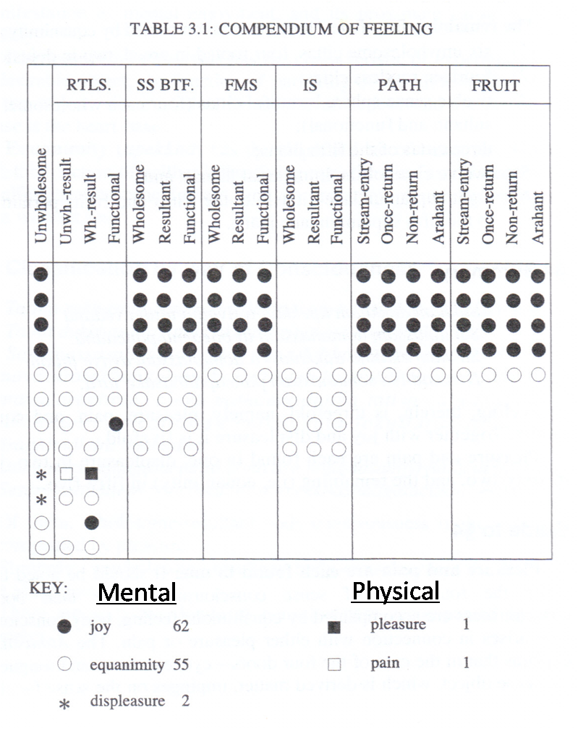

(e) Fetters (sanyojana)
To attain Nibbana and Arahantship, one has to eradicate the Ten Fetters (Samyojanas). Samyojanas are the bonds or fetters that bind a person to the cycle of existence (samsara). It impedes progress to liberation (emancipation).
The following table illustrates the stages of accomplishment of Sainthood and the eradication of the 10 fetters towards the attainment of Nibbana:
Fetters (Samyojanas) | Explanation & Details | Sainthood – to accomplish :
1. Self-illusion (sakkayaditthi) | View 5 aggregates as permanent entity, like soul. Illusion of self rather than dependent origination | Sotapanna (Stream winner) Eradicates 1–3 fetters  Reborn 7 times at most either in human or Brahma realm & not in woeful realms.  Gain confidence in Triple Gem & would not violate 5 precepts.
2. Doubts (vicikiccha) | Doubts about Buddha, Dhamma, Sangha & Buddha’s teachings
3. Indulge in wrongful rites & ceremonies (silabbata paramasa) | Practice wrong rites against moral conduct.
4. Sense-desire (kamaraga) | Attachment to sensual pleasures. | Sakadagami (Once Returner)  Eradicates 1-3 fetters & weakens 4&5 fetters. Reborn once in human realm.  Anagami (Non Returner)  Eradicates 1-5 fetters. Reborn in pure abodes till Arahantship.
5. Hatred (patigha) | Aversion or attachment to unpleasurable sense objects
6. Attachment to Rupa Jhanas & Form-sphere (Ruparaga) | Attachment to Form Realms | Arahant  Eradicated 1-5 & 5 other subtle fetters (6-10).  Not subject to rebirth as he does not accumulate fresh kamma.  Experience bliss of Nibbana.  If as human, he is not wholly free from physical suffering.
7. Attachment to Arupa Jhanas & Formless-sphere (Aruparaga) | Attachment to Formless Realms
8. Conceit (māna) | One of occasional unwholesome mental states
9. Restlessness (uddhacca) | One of common unwholesome mental states
10. Not-knowingness or Ignorance (avijja) | Root of all craving key to kamma & rebirth

(f) Bhavanga citta
19 cittas perform this function of Bhavanga (life-continuum) (p. 126), namely:
- 2 investigating
- 8 great resultants
- 5 fine-material sphere resultants and
- 4 immaterial sphere resultants
The same type of consciousness performs the 3 functions of rebirth-linking, life-continuum, and death (p.125).
- At the moment of conception - this type of consciousness arises linking the new existence to the old one
- Throughout the course of life – this same type of consciousness arises countless times as the passive flow of the bhavanga, maintaining the continuity of existence
- At death – this same type of consciousness again occurs as the passing away from the old existence.

