
YOUNG MEN’S BUDDHIST ASSOCIATION
COLOMBO-SRI LANKA
EXAMINATION 2019
Grade | : Diploma | Date | : 30th June 2019
Subject | : Abhidhamma | Time | : 3 hours
Answer 5 questions (Each question carries 20 marks)

Q1. Indicate the compendium of Doors and explain total consciousness can arise through EYE DOOR.

Ans 1.
(Reference: YMBA Guide Bk 4, chp. II, p.123-127; Abhi Sangaha, chp. III. p.129-132)
In the compendium of Doors (Dvara Sangaha) there are six doors, namely eye door, ear door, nose door, tongue door, body door, and mind door. Therein, the eye itself is the eye door, the ear is the ear door, and so forth.

The term door is used metaphorically in the Abhidhamma to denote the media through which the mind interacts with the objective world. Six doors of cognition are recognized: the six sense doors by which the citta and cetasikas go out to meet the object and by which objects enter into the range of the citta and cetasikas.

Five of the doors are material phenomena (rupā), namely, the sensitive matter (pasādarūpa) in each of the five sense organs. Each of these serves as a door by which the citta and cetasikas occurring in a cognitive process gain access to their objects, and by which the objects become accessible to the cittas and cetasikas.
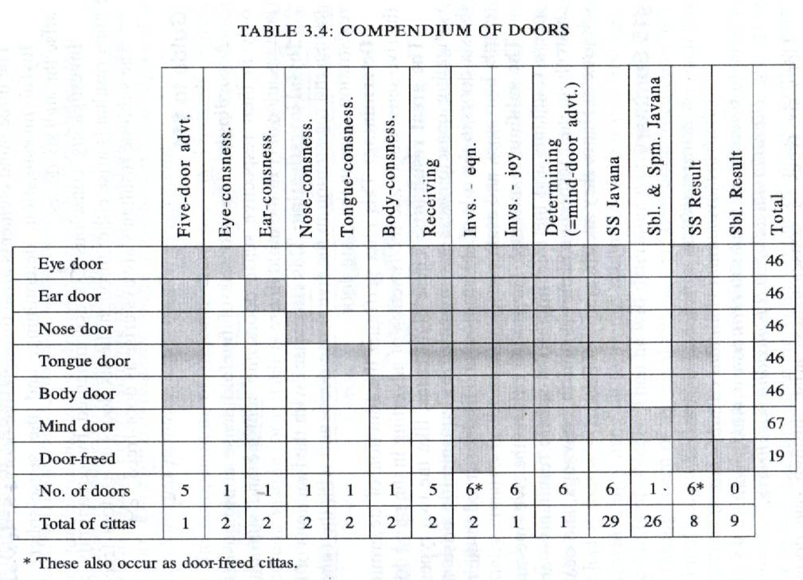

Eye-sensitivity is the door for cittas belonging to an eye door process, enabling them to cognize visible forms through the eye. The same holds for the other sensitivities of the sense organs in relation to their respective processes and objects.

46 types of consciousness (excluding bhavanga cittas, which are mind door cittas; and not double counting the 3 investigating cittas) arise in the eye door according to circumstances:

17 Thought Moments  (Eye-door Process) |  | Function | Cittas | Total
1 | Past Life-continuum (Atīta Bhavanga) | Rebirth-linking, Life-continuum, and Death | 2 Investigating  8 Great Resultants  5 FM Sphere Resultants  4 Imm. Sphere Resultants | 19
2 | Vibrational Life-continuum  (Bhavanga-Calana) | Life continuum (Bhavanga) |  | 19
3 | Arrest Bhavanga (Bhavanga Upaccheda) | Life continuum (Bhavanga) |  | 19
4 | Five-door adverting | Adverting (āvajjana) | 1 Five Door Adv. | 1
5 | Eye-consciousness | Seeing | 2 Eye | 2
6 | Receiving (Sampaticchanā) | Receiving (Sampatichannā) | 2 Receiving | 2
7 | Investigating (Satīranā) | Investigating (Santīranā) | 3 Investigating | 3
8 | Determining (Votthapana) | Determining (Votthapana) | 1 Mind Door Adv. | 1
9 | Javana | Javana – enjoying the object | 12 Unwholesome,  8 Great Wholesome,  8 Great Functional  1 Smile Producing | 29
10 | Javana | Javana – enjoying the object |  | 29
11 | Javana | Javana – enjoying the object |  | 29
12 | Javana | Javana – enjoying the object |  | 29
13 | Javana | Javana – enjoying the object |  | 29
14 | Javana | Javana – enjoying the object |  | 29
15 | Javana | Javana – enjoying the object |  | 29
16 | Registration (Tadārammana) | Registration (Tadārammana) | 8 beautiful resultants  3 investigating | 11
17 | Registration (Tadārammana) | Registration (Tadārammana) | 8 beautiful resultants  3 investigating | 11

Q2. Explain Door freed consciousness and indicate the total Rebirth Linking (PRATISANDI) separately.

Ans 2.
(Reference: Abhi Sangaha, chp. III. p. 132, p. 138)
Door-freed consciousness occur by way of its function as rebirth-linking, life-continuum and death. They do not occur in the six sense doors of eye-door, ear-door, nose-door, tongue-door, body-door and mind-door because they do not receive any new object but apprehend only the object determined by the last cognitive process of the preceding existence.

19 cittas are door freed:
- 2 investigating cittas accompanied by equanimity
- 8 great resultants - arise either through six sense doors in the role of registration or as door-freed in the roles of rebirth-linking, life-continuum and death.
- 9 sublime resultants – always arise as door-freed.

The object of this citta can be of six kinds: any of the 5 sense objects, either past present or future, or it can be a metal object.

In all three of its functions, this citta retains the same object from the rebirth moment to the moment of decease:
- That same object is grasped at the moment of rebirth by the relinking citta;
- during the course of life it is held to by every bhanvaga ciita;
- and at the moment of death it is held to by the death citta.

The object of the door-freed citta in any given existence is generally identical with the object of the last cognitive process in the immediately preceding existence. The object will present itself to the last cognitive process, determined by previous kamma and present circumstance. This object can be one of 3 kinds:
- Kamma - good or evil deed performed earlier during the same lifetime.
- Sign of kamma (kammanimitta) - an object or image associated with the good or evil deed that is about to determine rebirth or an instrument used to perform it. For example, a devout person may see the image of a monk or temple, a physician may see the image of patients, a butucher may hear the groans of slaughtered cattle or see an image of a butcher knife.
- Sign of destiny (gatinimitta) – a symbol of the realm into which the dying person is about to be reborn. For example, a person heading for a heavenly rebirth may see celestial mansions, a person heading for an animal rebirth may see forests or fields, a person heading for a rebirth in hell may see infernal fires.

The function exercised at conception is called rebirth-linking because it links the new existence to the previous one. The citta that performs this function, the rebirth-linking (patisandhi) citta, occurs once in any individual existence, at the moment of rebirth. After the parisandhi citta has arisen and fallen away, it is then followed by the bhavanga citta, which is a resultant citta of the same type as parisandhi citta but which performs a different function, namely the function of preserving the continuity of the individual existence.

Q3. Please explain GROSS MATERIAL PHENOMENA and NON GROSS MATERIAL PHENOMENA.

Ans 3.
(Reference: YMBA Guide Bk 3, chp. II, p.103; Abhi Sangaha, chp. VI. p.244 & 245)
Olarika rupa refers to gross, proximate, and impinging material phenomena. It is the material phenomena that are instrumental in the genesis of sense consciousness, and implying nothing about the relative size or nearness of the object.

These phenomena are twelve-fold:
- The Five sensitive organs - Eye-sensitivity, Ear-sensitivity, Nose-sensitivity, Tongue-sensitivity & Body-sensitivity.
- The Seven objective data - Visible form (Rūpa), Sound (Sadda), Smell (Gandha), Taste (Rasa) and Tangibility (= 3 great essentials: earth, fire & air. Cohesion is excluded.)

These phenomena that come in contact with the organs are called Gross as these are coarse and rough.

These Gross material phenomena are called proximate phenomena (Santike Rupa) since these are easily comprehended even from a distance.

These phenomena are also called as impinging material phenomena (Sappatigha Rupa) since the physical organs and the objects are subject to impinge on each other.

Those material phenomena (the balance 16) which do not directly contribute to the arising of sense consciousness are called subtle or non-gross (Sukhuma rupa), distant (Dūre Rupa), and non-impinging (Appatigha Rupa), again regardless of their size and distance.

Q4. The origination of Human body (Rupakanda) is depend on four modes. Discribe four condition and the " RUPA " thus created.

Ans 4.
(Reference: Abhi Sangaha, chp. VI. p.236, 246 & 252)
The four modes of origin of matters (Rupa Samutthana) are:
- Kamma (Kammaja Rupa / Kamma Samuttāna Rūpa )
- Consciousness (Cittaja Rupa / Citta Samuttāna Rūpa )
- Temperature (Utuja Rupa / Utu Samuttāna Rūpa )
- Nutriment (Āhāraja Rupa / Āhāra Samuttāna Rūpa )
Each produces matters in groups known as rūpakalāpas. There are a total of 21 groups in 4 modes.

Rupa found in Groups Possess Four salient characteristics:
- They arise together
- They cease together
- They have a common base / dependence
- They coexist
The Abhidhamma enumerates 28 types of material phenomena as follows:
Concretely Produced Matter (18)  (Nipphannarūpa) | Non-Concrete Matter (10)  (Anipphannarūpa)
I. Great Essentials (Mahābhūta) (4)  - Extension/Earth element (Pathavī dhātu) *  - Cohesion/Water element (Āpo dhātu) *  - Heat/Fire element (Tejo dhātu) *  - Motion/Air element (Vāyo dhātu) *  II. Sensitive Phenomena (Pasādarūpa) (5)  - Eye-sensitivity (Cakkhu-pasāda)  - Ear-sensitivity (Sota-pasāda)  - Nose-sensitivity (Ghāna-pasāda)  - Tongue-sensitivity (Jivhā-pasāda)  - Body-sensitivity (Kāya-pasāda)  III. Objective Phenomena (Gocararūpa) (4)  - Visible form (Rūpa) *  - Sound (Sadda)  - Smell (Gandha) *  - Taste (Rasa) *  *Tangibility (= 3 elements: earth, fire & air. Cohesion is excluded.)  IV. Sexual Phenomena (Bhāvarūpa) (2)  - Femininity (Ittha)  - Masculinity (Purisa)  V. Heart Phenomenon (Hadayarūpa) (1)  - Heart base (Hadayavatthu)  VI. Life Phenomenon (Jīvitarūpa) (1)  - Material Physical  Life faculty (Jīvitindriya)  VII. Nutritional Phenomenon (Kabalīkārāhāra) (1)  - Nutriment (Āhāra) * | VIII. Limiting Phenomenon (Paricchedarūpa) (1)  - Space element (Ākāsadhātu)  IX. Communicating Phenomena (Viññattirūpa) (2)  - Bodily intimation (Kāya viññatti)  - Vocal intimation (Vacī viññatti)  X. Mutable Phenomena (Vikārarūpa) (3)  - Lightness (Lahutā)  - Malleability (Mudutā)  - Wieldiness (Kammaññatā)  (plus two intimations)  XI. Characteristics of Matter (Lakkhanarūpa) (4)  - Production (Upacaya)  - Continuity (Santati)  - Decay (Jaratā)  - Impermanence (Aniccatā)
Q5. What are the different type of feeling, classify the consciousness accordingly.

Ans 5.
(Reference: Abhi Sangaha, chp. III. p.115-119)
Feeling (vedana) is a universal mental factor, the cetasika with the function of experiencing the “flavour” of the object. Since some sort of feeling accompanies every citta, feeling serves as an important variable in terms of which consciousness can be classified.

Feeling may be analyzed as either three fold or five fold.

When it is analyzed simply in terms of its affective quality, it is threefold:
1. Pleasant (physical and mental)
2. Painful (physical and mental)
3. Neither-painful-nor-pleasant

The five fold analysis of feeling (vedanā) are:

Physical:
1. Pleasure (Sukha) – has the characteristics of experiencing a desirable tangible object, the function of intensifying associated states, manifestation as bodily enjoyment, and its proximate cause is the body faculty.
2. Pain (Dukkha) – has the characteristics of experiencing an undesirable tangible object, the function of withering associated states, manifestation as bodily affliction, and its proximate cause is also the body faculty.

Mental:
1. Joy (Somannasa) – has the characteristics of experiencing a desirable object, the function of partaking of the desirable aspect of the object, manifestation as mental enjoyment, and its proximate cause is tranquillity.

2. Displeasure (Dommanasa) – has the characteristics of experiencing an undesirable object, the function of partaking of the undesirable aspect of the object, manifestation as mental affliction, and its proximate cause is the heart base.

3. Equanimity (Upekkhā) - has the characteristics of being felt as neutral, the function of neither intensifying nor withering of associated states, manifestation as peacefulness, and is proximate cause is consciousness without zest.

The number of consciousness accompanied by each of these fivefold feelings are:
Feeling  (Vedanā) | Pleasure  (Sukha) | Pain  (Dukha) | Joy  (Somannasa) | Displeasure  (Domanassa) | Equanimity  (Upekha)
Consciousness (Citta) | 1 | 1 | 62 | 2 | 55

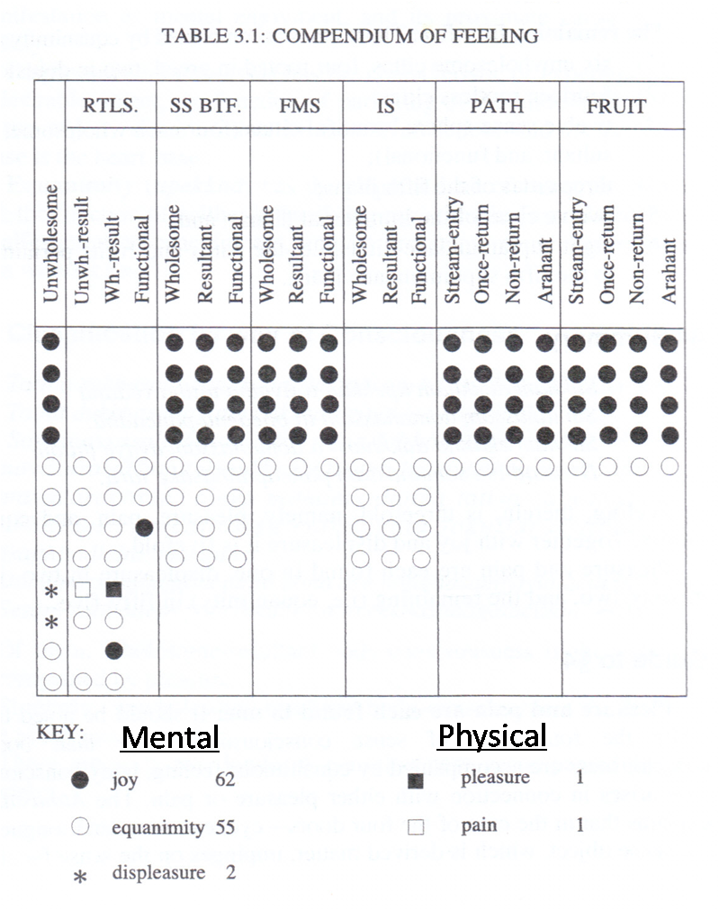

Q6. Write short notes on four of the following:
- KARMAJA RUPA (VOLITION)
(Ref: Abhi Sangaha, chp. VI. p.247)
- It is the volitions of the 25 kinds of wholesome and unwholesome cittas that produce material phenomena (12 unwholesome + 8 SS wholesome + 5 FMS wholesome).
- The volitions that developed in the previous life span, produces rupas of the new life in the different worlds.
- Arising of these rupas commences from the time of conception as a new Being and continues until the last breath.
- 18 kinds of material phenomena are produced by kamma – 8 inseparables, 5 sensitivities, 2 sex faculties, life faculty, heart-base and space.

- MENTAL FACTORS (CETASIKA)
(Ref: Abhi Sangaha, chp. II. p. 76-79, 91)
Cetasikas are mental phenomena that occur in immediate conjunction with citta, and assist citta by performing more specific tasks in the total act of cognition. Mental factors have four characteristics that are common to all:
- Arising together with citta (ekuppāda)
- Ceasing together with citta (ekaniroda)
- Having the same object as citta (ekālambana)
- Having the same base as citta (ekavatthuka)

The Abhidhamma philosophy recogninzes 52 cetasikas classifies into four broad categories:
- Seven universals (sabbacittasādhārana)
- Six occasionals (pakinnaka)
- 14 unwholesome factors (akusala)
- 25 beautiful factors (sobhana)

The first two categories are designated as aññāsamāna or ethically variable, which literally means “common to the other”. These 13 are so called because they are common to both beautiful & non-beautiful cittas.

The seven universals are linked with every type of cittas.
The six occasionals are linked with cittas in appropriate ways.
The 14 unwholesome factors are linked only with unwholesome citta types.
The 25 beautiful factors are linked only with beautiful citta types.

- DETERMINING (VOTTAPANA)
(Ref: Abhi Sangaha, chp. I. p. 44; chp. III. p.123, 126)
In the case of a cognitive process through any of the five sense doors, following the citta that performs the function of seeing, etc., there arise in succession cittas that perform the function of receiving (sampaticchanā), investigating (santiranā), determining (votthapana) the object.

There is no distinct citta known as determining consciousness. It is the same type of citta, a rootless functional consciousness accompanied by equanimity that performs the function of mind-door adverting in the mind-door process and the function of determining in a process in the five physical sense doors.

When it occurs in a five-door process it is called votthapanacitta, determining consciousness. Its function is to determine, or define, the object that has been cognized by sense consciousness. In the five-door process, determining consciousness succeeds the investigating consciousness. Fter the investigating consciousness has examined the object, the determining consciousness discriminates it.

- SOTHAPATTIMAGGA
(Ref: Abhi Sangaha, chp. I. p.65-67)
Sotāpatti-magga cittam is the path consciousness of stream entry. It is one of four types of supramundane wholesome consciousness. Supramundane consciousness is consciousness that pertains to the process of transcending (uttara) the world (loka) consisting of the five aggregates of clinging. This type of consciousness leads to liberation from samsara, the cycle of birth and death, and to the attainment of Nibbana, the cessation of suffering. There are eight supramundane cittas. These pertain to the four stages of enlightenment - stream-entry, once returning, non-returning, and Arahantship. Each stage involves two types of cittas, path consciousness (maggacitta) and fuition consciousness (phalacitta).

All supramundane cittas take as object the unconditioned reality, Nibbāna, but they differ as paths and fruits according to their functions. The path consciousness has the function of eradicating (or permanent attenuating) defilements. The fruition consciousness has the function of experiencing the degree of liberation made possible by corresponding path. The path consciousness is a kusalacitta, a wholesome state; the fruition consciousness is a vipakacitta, a resultant.
Each path citta arises only once, and endures only for one mind-moment; it is never repeated in the mental continuum of the person who attains it. The corresponding fruition citta initially arises immediately after the path moment, endures for two or three mind-moments. Subsequently it can be repeated, and with practice can be made to endure for many mind-moments, in the supramundane absorption called fruition attainment.

The paths and fruits are attained by the method of meditation called the development of insight (vipasanābhāvanā). This type of meditation involves the strengthening of the faculty of wisdom (pañña). By sustained attention to the changing phenomena of mind and matter, the meditator learns to discern their true characteristics of impermanence, suffering and non-self. When these insight gain full maturity, they issue in supramundane paths and fruits.

The entry upon the irreversible path to liberation is called stream-entry, and the citta that experiences this attainment is the path consciousness of stream entry. The noble disciple who has reached the experience of stream entry, the path factors o f the Noble Eightfold Path become fixed in destiny, and flow like a stream leading to Nibbana.

The path citta of stream entry has the function of cutting off the first three fetters of wrong views of self, doubt about the Triple Gem, and clinging to rites and ceremonies.

One who has undergone the experience of stream-entry is assured of reaching final deliverance in maximum of seven lives, and of never being born in any of the woeful planes of existence.

- HINDRANCES (NIVARANA)
(Ref: Abhi Sangaha, chp. I. p.54-58)
Jhānas are attained by the method of meditation called the development of calm or serenity (samathabhāvana). This type of meditation involves the strengthening of the faculty of concentration (samādhi). By fixing the mind on single selected object, all mental distraction is eliminated. The adverse states opposed to concentration are burned up and suppressed, and the mind becomes fully absorbed in its object. The adverse states are the five hindrances (nīrvarana) of sensual desire, ill will, sloth and torpor, restlessness and worry, and doubt.

Jhāna factors inhibits hindrances in the following manner:
- Initial application (vitakka) inhibits the hindrance of sloth and torpor.
- Sustained application (vicāra) inhibits the hindrance of doubt.
- Zest (pīti) inhibits the hindrance of ill will.
- Happiness, or pleasant mental feeling (sukha) inhibits the hindrance of restlessness and worry.
- One-pointedness (ekaggatā) inhibits sensual desire.

Q7. Decline one of the following in the cases
  - NATTU (GRAND SON)
Case Singular Plural
Nominative Nattā Nattāro
Accusative Nattāraŋ Nattāre; Nattāro
Ablative Nattārā Nattārebhi; Nattārehi
Dat. Gen. Nattu; nattuno, nattussa Nattārānaŋ; Nattānaŋ
Locative Nattari Nattāresu
Vocative Natta; Nattā Nattāro

  - DAREKA (YOUNG GIRL) – or Dārikā?

  - VANARA (MONKEY)
Case Singular Plural
Nominative Vānaro Vānarā
Accusative Vānaraŋ Vānare
Instrumental Vānarena Vānarebhi; Vānarehi
Dative Vānarāya, Vānarassa Vānarānaŋ
Ablative Vānarā, Vānaramhā, Vānarasmā Vānarebhi; Vānarehi
Genitive Vānarassa Vānarānaŋ
Locative Vānare; Vānaramhi; Vānarasmiŋ Vānaresu
Vocative Vānara; Vānarā Vānarā

  - BUPATHI (KING)
Case Singular Plural
Nom. & Voc. Bupathi Bupathī; Bupathīni
Accusative Bupathiŋ Bupathī; Bupathīni
Instrumental Bupathinā Bupathībhi; Bupathīhi
Dat. & Gen. Bupathino, Bupathissa Bupathīnaŋ
Ablative Bupathinā, Bupathimhā, Bupathismā Bupathībhi; Bupathīhi
Locative Bupathini; Bupathimhi; Bupathismiŋ Bupathisu; Bupathīsu

