YOUNG MEN’S BUDDHIST ASSOCIATION
COLOMBO-SRI LANKA
EXAMINATION 2017
Grade | : Diploma | Date | : 25th June 2017
Subject | : Abhidhamma | Time | : 3 hours
Answer any five questions

Q1. Please indicate different functions of the consciousness and give classifications of JAVANA functions.
Ans 1.
(Reference: Abhi Sangaha, chp. III. p.125-129)
In all, the 89 consciousness perform 14 separate functions as follows:
14 Functions
1 | Rebirth-linking (Patisandhi) | 8 | Touch (Phusana)
2 | Life-continuum (Bhavanga) | 9 | Receiving (Sampaticchanā)
3 | Adverting (Āvajjana) | 10 | Investigating (Satīranā)
4 | See (Dassana) | 11 | Determining (Votthapana)
5 | Hear (Savana) | 12 | Javana
6 | Smell (Ghāyana) | 13 | Registration (Tadārammana)
7 | Taste (Sāyana) | 14 | Death (Cuti)
Functions are exercised either
- at distinct phases within the cognitive process (3-13)
- or on occasions when consciousness is occurring outside the cognitive process, that is, the process freed (vithimutta) consciousness (1, 2 & 14).

55 cittas are classified as performing solely the function of Javana and do not perform any other functions. They are:
- 12 unwholesome cittas
- 21 wholesome cittas
- 4 resultants (i.e. the supramundane fruits)
- 18 functional cittas (the two adverting cittas being excepted)
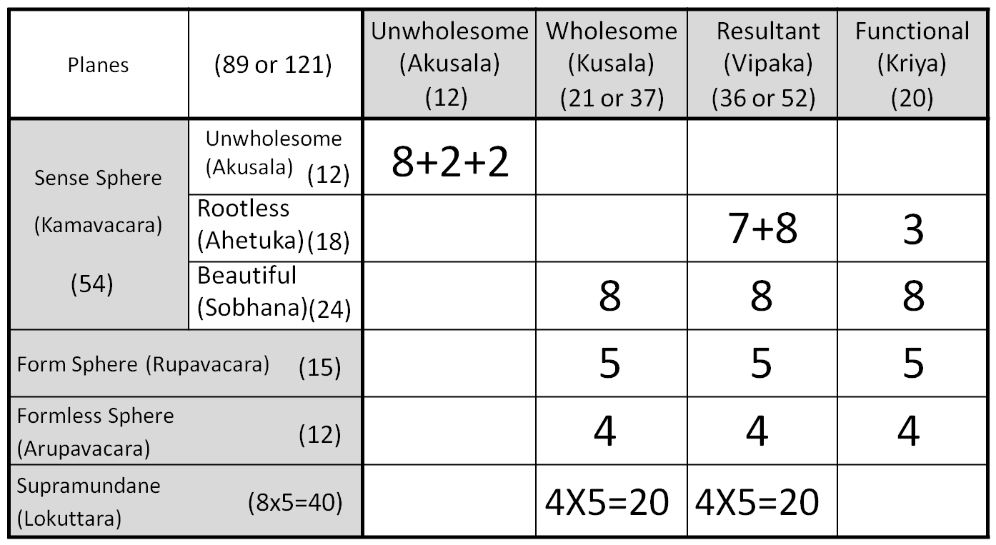
1
__

Q2. Explain the places or locations of arising of consciousness.

Ans 2.
(Reference: Abhi Sangaha, chp. I. p.29 &30)
There are four planes of existence (bhumi) in which consciousness arise. These consciousness are classified into four corresponding spheres (avacara). Three are mundane: the Sense Sphere (Kāmāvacara), the Fine Material Sphere (Rūpāvacara), and the Immaterial Sphere (Arūpāvacara); the fourth plane is the Supramundane (Lokuttara).

The locality frequented by a particular sphere (avacara) of cittas is the plane of existence (bhumi), designated by similar name, that is, the Sensuous, the Fine Material, and Immaterial planes of existence. Lokuttara has no locality.

Although Spheres of Consciousness and Planes of Existence have a close connection, they are not identical. The Spheres of Consciousness are categories for classifying types of cittas, the planes of existence are realms or worlds into which beings are reborn and in which they pass their lives.

A definite relationship nevertheless exists between Spheres of Consciousness and the Planes of Existence. Cittas of a particular Sphere of Consciousness typically arise in the corresponding Plane of Existence, and tend to arise most often there.

However, cittas of a particular Sphere is not tied to the corresponding plane, but may arise in other Planes of Existence as well. For instance, fine-material and immaterial sphere cittas can arise in the sensuous plane, and vice versa.

But still a connection is found, in that a sphere of consciousness is typical for the plane that shares its name.

Moreover, kammically active cittas of any particular sphere, tend to produce rebirth into the corresponding plane of existence.

Hence the tie between the Spheres of Consciousness and the corresponding Planes of Existence is extremely close.

Q3. Indicate in detail gross materials phenomena (OLARIKA RUPA) and non gross materials phenomena (SUKHUMA RUPA).

Ans 3.
(Reference: YMBA Guide Bk 3, chp. II, p.103; Abhi Sangaha, chp. VI. p.244 & 245)
Olarika rupa refers to gross, proximate, and impinging material phenomena. It is the material phenomena that are instrumental in the genesis of sense consciousness, and implying nothing about the relative size or nearness of the object.

These phenomena are twelve-fold:
- The Five sensitive organs - Eye-sensitivity, Ear-sensitivity, Nose-sensitivity, Tongue-sensitivity & Body-sensitivity.
- The Seven objective data - Visible form (Rūpa), Sound (Sadda), Smell (Gandha), Taste (Rasa) and Tangibility (= 3 great essentials: earth, fire & air. Cohesion is excluded.)

These phenomena that come in contact with the organs are called Gross as these are coarse and rough.

These Gross material phenomena are called proximate phenomena (Santike Rupa) since these are easily comprehended even from a distance.

These phenomena are also called as impinging material phenomena (Sappatigha Rupa) since the physical organs and the objects are subject to impinge on each other.

Those material phenomena (the balance 16) which do not directly contribute to the arising of sense consciousness are called subtle or non-gross (Sukhuma rupa), distant (Dūre Rupa), and non-impinging (Appatigha Rupa), again regardless of their size and distance.

Q4. Mention Rupa Samutthana (origination of matters) classified under different groups and write name of 28 material Phenomena.

Ans 4.
(Reference: Abhi Sangaha, chp. VI. p.236, 246 & 252)
The four modes of origin of matters (Rupa Samutthana) are:
- Kamma (Kammaja Rupa / Kamma Samuttāna Rūpa )
- Consciousness (Cittaja Rupa / Citta Samuttāna Rūpa )
- Temperature (Utuja Rupa / Utu Samuttāna Rūpa )
- Nutriment (Āhāraja Rupa / Āhāra Samuttāna Rūpa )

Each produces matters in groups known as rūpakalāpas. There are a total of 21 groups in 4 modes.

Rupa found in Groups Possess Four salient characteristics:
- They arise together
- They cease together
- They have a common base / dependence
- They coexist

The Abhidhamma enumerates 28 types of material phenomena as follows:
Concretely Produced Matter (18)  (Nipphannarūpa) | Non-Concrete Matter (10)  (Anipphannarūpa)
I. Great Essentials (Mahābhūta) (4)  - Extension/Earth element (Pathavī dhātu) *  - Cohesion/Water element (Āpo dhātu) *  - Heat/Fire element (Tejo dhātu) *  - Motion/Air element (Vāyo dhātu) *  II. Sensitive Phenomena (Pasādarūpa) (5)  - Eye-sensitivity (Cakkhu-pasāda)  - Ear-sensitivity (Sota-pasāda)  - Nose-sensitivity (Ghāna-pasāda)  - Tongue-sensitivity (Jivhā-pasāda)  - Body-sensitivity (Kāya-pasāda)  III. Objective Phenomena (Gocararūpa) (4)  - Visible form (Rūpa) *  - Sound (Sadda)  - Smell (Gandha) *  - Taste (Rasa) *  *Tangibility (= 3 elements: earth, fire & air. Cohesion is excluded.)  IV. Sexual Phenomena (Bhāvarūpa) (2)  - Femininity (Ittha)  - Masculinity (Purisa)  V. Heart Phenomenon (Hadayarūpa) (1)  - Heart base (Hadayavatthu)  VI. Life Phenomenon (Jīvitarūpa) (1)  - Material Physical  Life faculty (Jīvitindriya)  VII. Nutritional Phenomenon (Kabalīkārāhāra) (1)  - Nutriment (Āhāra) * | VIII. Limiting Phenomenon (Paricchedarūpa) (1)  - Space element (Ākāsadhātu)  IX. Communicating Phenomena (Viññattirūpa) (2)  - Bodily intimation (Kāya viññatti)  - Vocal intimation (Vacī viññatti)  X. Mutable Phenomena (Vikārarūpa) (3)  - Lightness (Lahutā)  - Malleability (Mudutā)  - Wieldiness (Kammaññatā)  (plus two intimations)  XI. Characteristics of Matter (Lakkhanarūpa) (4)  - Production (Upacaya)  - Continuity (Santati)  - Decay (Jaratā)  - Impermanence (Aniccatā)

Q5. Indicate compendium of Doors (dvara sangaha) and explain how many consciousness arise in Eye Door and Mind Door.

Ans 5.
(Reference: YMBA Guide Bk 4, chp. II, p.123-127; Abhi Sangaha, chp. III. p.129-132)
In the compendium of Doors (Dvara Sangaha) there are six doors, namely eye door, ear door, nose door, tongue door, body door, and mind door. Therein, the eye itself is the eye door, the ear is the ear door, and so forth.

The term door is used metaphorically in the Abhidhamma to denote the media through which the mind interacts with the objective world. Six doors of cognition are recognized: the six sense doors by which the citta and cetasikas go out to meet the object and by which objects enter into the range of the citta and cetasikas.

Five of the doors are material phenomena (rupā), namely, the sensitive matter (pasādarūpa) in each of the five sense organs. Each of these serves as a door by which the citta and cetasikas occurring in a cognitive process gain access to their objects, and by which the objects become accessible to the cittas and cetasikas.

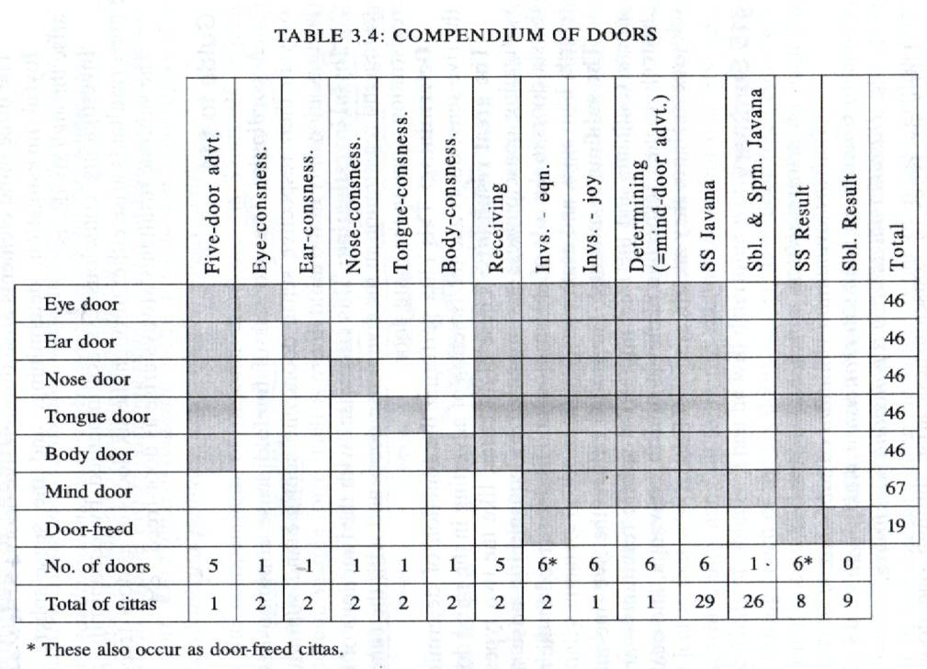

Eye-sensitivity is the door for cittas belonging to an eye door process, enabling them to cognize visible forms through the eye. The same holds for the other sensitivities of the sense organs in relation to their respective processes and objects.

46 types of consciousness (excluding bhavanga cittas, which are mind door cittas; and not double counting the 3 investigating cittas) arise in the eye door according to circumstances:
17 Thought Moments  (Eye-door Process) |  | Function | Cittas | Total
1 | Past Life-continuum (Atīta Bhavanga) | Rebirth-linking, Life-continuum, and Death | 2 Investigating  8 Great Resultants  5 FM Sphere Resultants  4 Imm. Sphere Resultants | 19
2 | Vibrational Life-continuum  (Bhavanga-Calana) | Life continuum (Bhavanga) |  | 19
3 | Arrest Bhavanga (Bhavanga Upaccheda) | Life continuum (Bhavanga) |  | 19
4 | Five-door adverting | Adverting (āvajjana) | 1 Five Door Adv. | 1
5 | Eye-consciousness | Seeing | 2 Eye | 2
6 | Receiving (Sampaticchanā) | Receiving (Sampatichannā) | 2 Receiving | 2
7 | Investigating (Satīranā) | Investigating (Santīranā) | 3 Investigating | 3
8 | Determining (Votthapana) | Determining (Votthapana) | 1 Mind Door Adv. | 1
9 | Javana | Javana – enjoying the object | 12 Unwholesome,  8 Great Wholesome,  8 Great Functional  1 Smile Producing | 29
10 | Javana | Javana – enjoying the object |  | 29
11 | Javana | Javana – enjoying the object |  | 29
12 | Javana | Javana – enjoying the object |  | 29
13 | Javana | Javana – enjoying the object |  | 29
14 | Javana | Javana – enjoying the object |  | 29
15 | Javana | Javana – enjoying the object |  | 29
16 | Registration (Tadārammana) | Registration (Tadārammana) | 8 beautiful resultants  3 investigating | 11
17 | Registration (Tadārammana) | Registration (Tadārammana) | 8 beautiful resultants  3 investigating | 11

The life-continuum (bhavanga) is called the mind door. Unlike the first five doors, the mind door (manodvarā) is not material but mental (nāma), namely bhavanga citta. When an object is to be cognized by a mind door process, the cittas belonging to that process gain access to the object solely through the mind door, without immediate dependence on any material sense faculty.

67 types of cittas occur in the mind door, including all 55 types of javana cittas.
Only 22 cittas do not occur in the mind door:
- Five-door adverting (1)
- Two sets of five-fold sense consciousness (10)
- Two type of receiving consciousness (2)
- Five fine-material resultants (5)
- Four immaterial resultants (4)
Q6. Draw a Diagram to show Eye Door thought process in ATI MAHANTARAMMANA CITTA VEETHI (Very great object) and name the function performed at each consciousness.

Ans 6.
Diagram of the Eye Door thought process 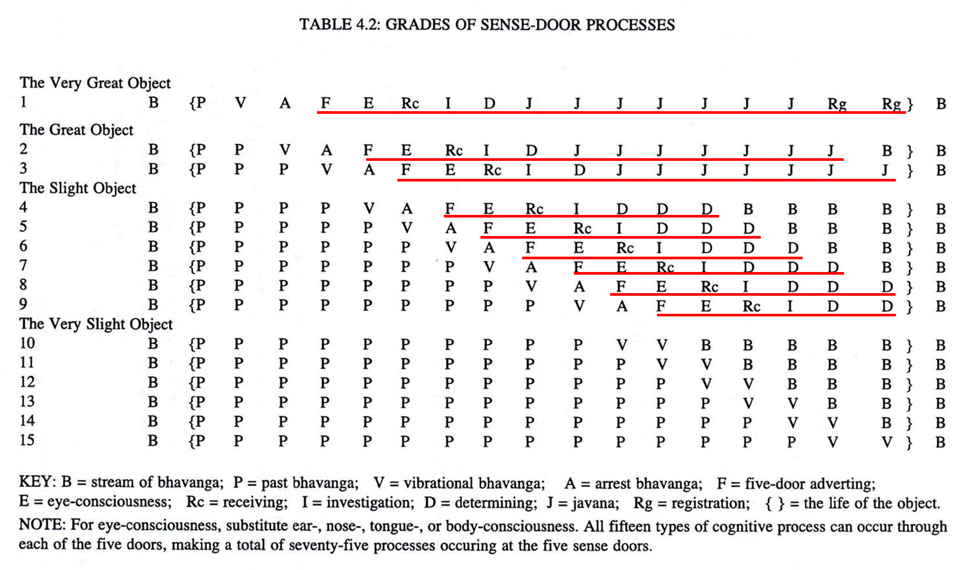

17 Thought Moments  (Eye-door Process) |  | Function | Cittas | Total
1 | Past Life-continuum (Atīta Bhavanga) | Rebirth-linking, Life-continuum, and Death | 2 Investigating  8 Great Resultants  5 FM Sphere Resultants  4 Imm. Sphere Resultants | 19
2 | Vibrational Life-continuum  (Bhavanga-Calana) | Life continuum (Bhavanga) |  | 19
3 | Arrest Bhavanga (Bhavanga Upaccheda) | Life continuum (Bhavanga) |  | 19
4 | Five-door adverting | Adverting (āvajjana) | 1 Five Door Adv. | 1
5 | Eye-consciousness | Seeing | 2 Eye | 2
6 | Receiving (Sampaticchanā) | Receiving (Sampatichannā) | 2 Receiving | 2
7 | Investigating (Satīranā) | Investigating (Santīranā) | 3 Investigating | 3
8 | Determining (Votthapana) | Determining (Votthapana) | 1 Mind Door Adv. | 1
9 | Javana | Javana – enjoying the object | 12 Unwholesome,  8 Great Wholesome,  8 Great Functional  1 Smile Producing | 29
10 | Javana | Javana – enjoying the object |  | 29
11 | Javana | Javana – enjoying the object |  | 29
12 | Javana | Javana – enjoying the object |  | 29
13 | Javana | Javana – enjoying the object |  | 29
14 | Javana | Javana – enjoying the object |  | 29
15 | Javana | Javana – enjoying the object |  | 29
16 | Registration (Tadārammana) | Registration (Tadārammana) | 8 beautiful resultants  3 investigating | 11
17 | Registration (Tadārammana) | Registration (Tadārammana) | 8 beautiful resultants  3 investigating | 11

Q7. Write short note of any FOUR of the following.
(i) Mental Factors (Cetasika)
(Ref: Abhi Sangaha, chp. II. P.76-79)
Cetasikas are mental phenomena that arise together with citta, and assist citta by performing specific tasks in the total act of cognition. The four characteristics of mental factors are:
- They arise together with citta (ekuppāda)
- They cease together with citta (ekanirodha)
- They have the same object as citta (ekālambana)
- They have the same base as citta (ekavatthuka)

There 52 mental factors classified into four broad categories:
- Seven Universals
- Six Occasionals
- 14 Unwholesome factors
- 25 beautiful factors.
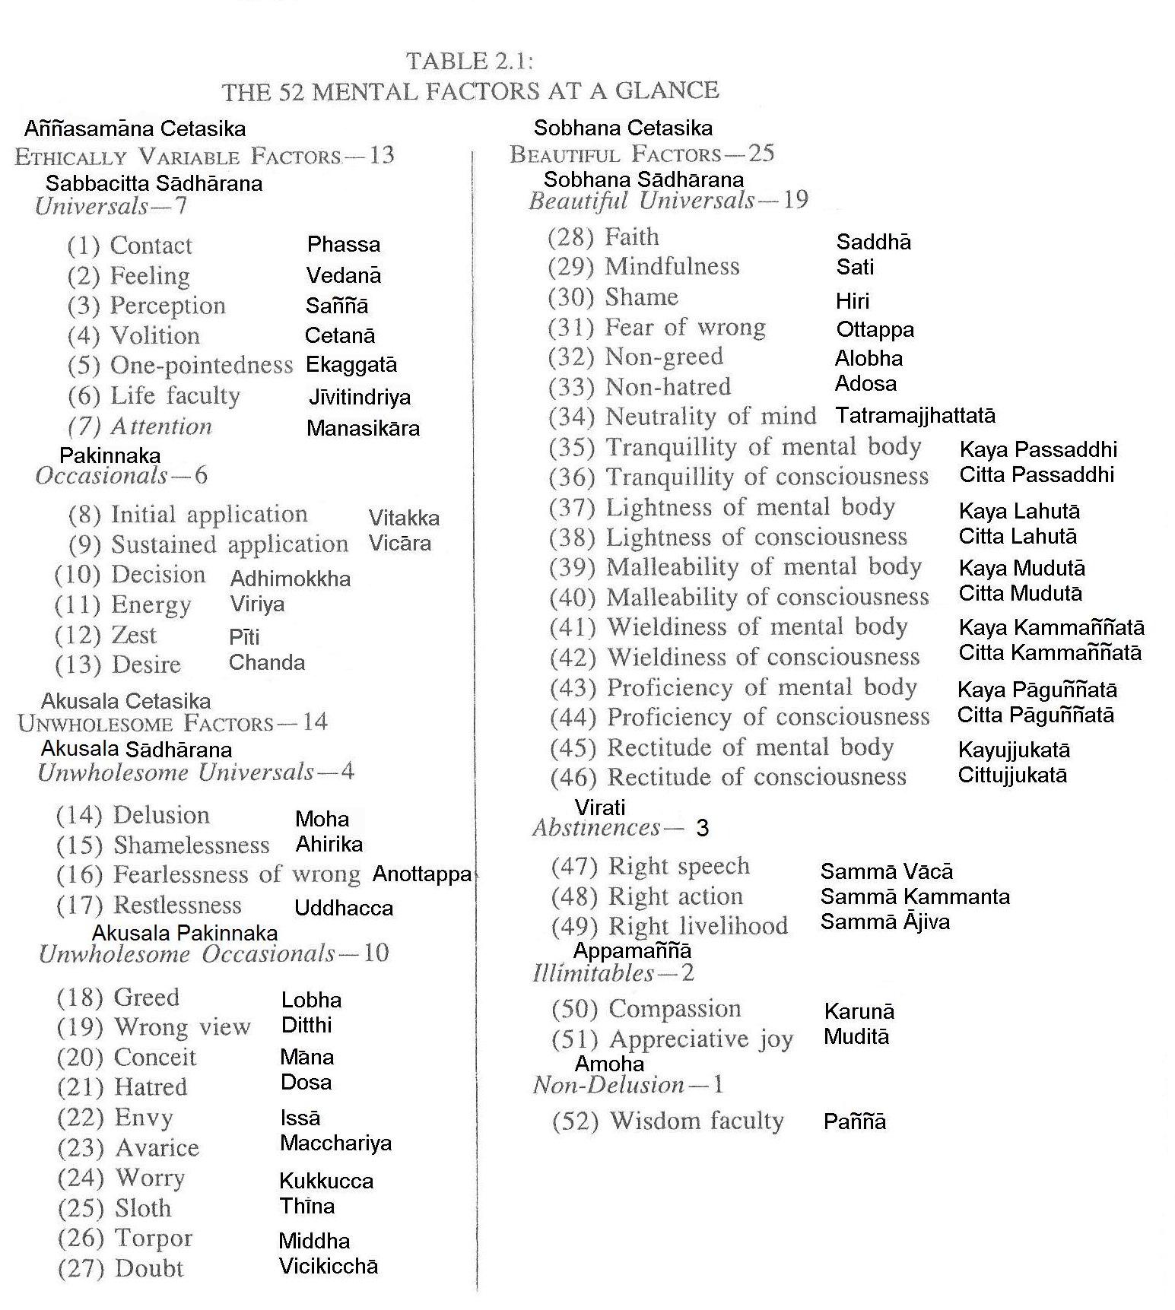

(ii). Initial application (Vitakka)
(Ref: Abhi Sangaha, chp. II. P.81 & 82)
Vitakka is the first of the five jhāna factors. It is the application of the mind to the object. Its characteristic is the directing of the mind onto the object. Its function is to strike at and thresh the object. It is manifested as the leading of the mind onto an object. Though no proximate cause is mentioned in the commentaries, the object may be understood as the proximate cause.

Ordinary vitakka simply applies the mind to the object. But when vitakka is cultivated through concentration it becomes a factor of jhāna. It is then termed appanā, the absorption of the mind in the object. Vitakka is also called sankappa, intention, and as such is distinguished as micchasankappa or wrong intention and sammasankappa or right intention. The latte is the second factor of the Noble Eightfold Path.

(iii) Energy (Viriya)
(Ref: Abhi Sangaha, chp. II. P. 82)
Viriya is the state or action of one who is vigorous. Its characteristic is supporting, exertion, and marshalling. Its function is to support its associated states. Its manifestation is non-collapse. Kits proximate cause is a sense of urgency (samvega) or a ground for arousing energy, that is, anything that stirs one to vigorous action. Just as new timbers added to an old house prevent it from collapsing, or just as a strong reinforcement enables the king’s army to defeat the enemy, so energy upholds and supports all the associated states and does not allow them to recede.

(iv) Heavens (Celestia World)
(Ref: Abhi Sangaha, chp. V. p.191 & 192)
The sensuous blissful plane consist of the human realm and six heavens. The six heavens are abodes of devas or gods. They have a longer life-span than the human world and a richer variety of sensual pleasures which, however, are inevitably impermanent. The six sense-sphere heavens are:
- The Realm of the Four Great Kings
- The Realm of the Thirty-three Gods
- The Realm of the Yama Gods
- The Delightful Realm
- The Realm of the Gods who rejoice in their own Creations
- The Realm of the Gods who lord over the Creations of Others.

The fine-material-sphere plane is sixteenfold. It is the realm of rebirth for those who have developed, during their life, one or another of the fine-material jhānas, and at the time of death still possess that jhāna in the sense that they y still have potential access to it, not having lost it owing to negligence and obsession by obstructive states.

The immaterial-sphere plane is fourfold. These are the four planes of rebirth for those who, at the time of death, possess an immaterial meditative attainment. Each immaterial attainment leads to rebirth into the corresponding realm.

(v) Rootless (Ahetuka)
(Ref: Abhi Sangaha, chp. I. p.40-41)

A root is a factor which helps to establish stability in a citta. There is a total of six roots:
- Three unwholesome roots: Greed, hatred and delusion
- Three wholesome roots: Non-greed, non-hatred and non-delusion.

Consciousness devoid of roots are called rootless consciousness. Cittas which lacks roots are weaker than those which possess them. Rootless cittas are 18 in numbers: 7 unwholesome-resultants, 8 wholesome-resultants and 3 functional.

